
Executive Director (Nursing)

Job Pack
August 2026

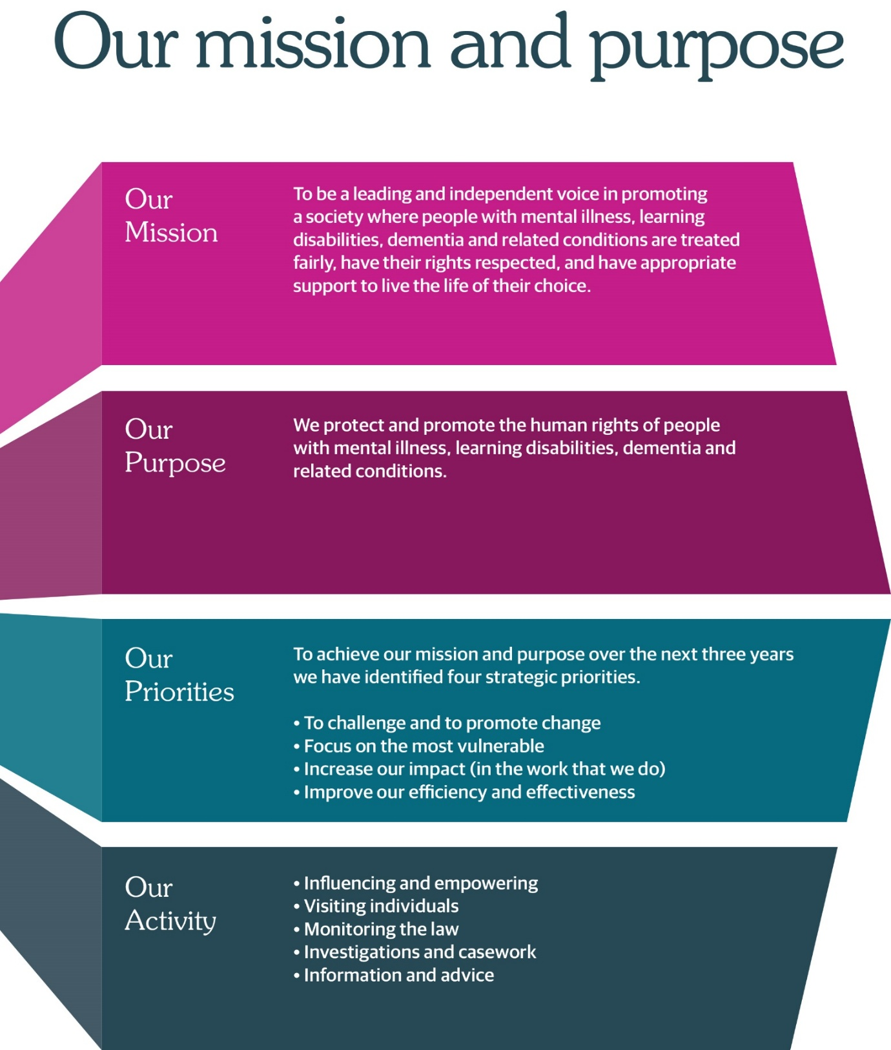

Message from the Chief Executive


Thank you for your interest in joining the Mental Welfare Commission for Scotland.

We are committed to creating a workplace where people feel valued, trusted and supported, and where inclusiveness, collaboration and excellence are at the heart of everything we do. As you consider a career with us, I hope this recruitment pack provides a helpful introduction to our organisation, our values and the opportunities available.

The work of the Commission is both unique and vitally important. We exist to protect and promote the human rights of people with mental illness, learning disabilities and related conditions across Scotland. Our workforce plays a central role in delivering this purpose, helping to ensure that some of the most vulnerable people in our society are treated with dignity, respect and fairness.

We are operating in a period of significant change for the mental health landscape in Scotland, with major reforms under discussion and a growing focus on rights-based approaches. Alongside this, we are delivering an ambitious programme of work set out in our Strategic Plan. As a result, there has never been a more exciting time to join the Commission.

If you share our commitment to human rights, public service and making a positive difference to people’s lives, I encourage you to apply. We welcome applications from people with diverse backgrounds, experiences and perspectives, and we look forward to learning more about what you could bring to our organisation.

Julie Paterson
Chief Executive

For further information on our organisation, please click on our web-link.
Our modern office is based in central Edinburgh, very close to Haymarket Railway station and is served with very good public transport links across Scotland. As an organisation, we work Scotland wide and serve different regions within our teams.
We offer:
- a comprehensive range of HR policies including policies to help balance commitments at work and home and flexible family friendly working arrangements
- training and development opportunities
- access to occupational health services
- access to an employee assistance programme
- access to staff benefits/staff discounts
- a cycle to work scheme
- access to the NHS pension scheme

The following information will help you with your application:
- job advert
- job description
- person specification
- terms and conditions of employment information sheet

We hope you are encouraged to apply and look forward to receiving your application.

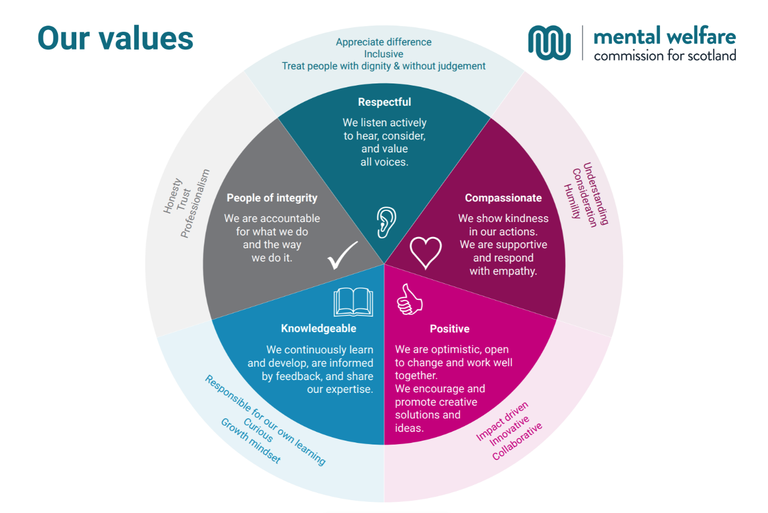

JOB ADVERT
Executive Director (Nursing)
Mental Welfare Commission for Scotland

Salary: £83,661 – £92,957
Hours: 35 per week
Contract: Permanent
Location: Edinburgh (hybrid)

The Mental Welfare Commission for Scotland (the Commission) is recruiting an Executive Director (Nursing) — a key values led, senior leadership role which is highly influential in the context of mental health, incapacity and human rights law in Scotland.

About us

The Commission is an independent statutory body established to protect and promote the human rights, welfare, and dignity of people with mental illness, learning disabilities, dementia, and related conditions. We ensure that care, treatment, and support are lawful, ethical, and aligned with the principles of human rights and equality. We operate independently of government, enabling us to speak with authority and impartiality on matters affecting some of Scotland’s most vulnerable people.

The role
The Executive Director (Nursing) is an established role at the Commission responsible for direct line management of a small multidisciplinary staff team and leading a portfolio of strategic and operational responsibilities that support the achievement of the Commission's vision, purpose and statutory duties.
As a member of the Executive Leadership Team, the post holder shares collective responsibility for leading the Commission's work to safeguard the rights and welfare of individuals, promote compliance with mental health and incapacity legislation, and improve standards of care and practice across Scotland.
As the Commission's professional nursing lead, the post holder will also provide leadership on issues affecting people with mental illness, learning disabilities, dementia and related conditions, as well as broader adult and child protection matters.
The role requires strong national leadership in mental health and learning disability nursing, influencing policy, practice and service development across Scotland while providing expert advice on complex ethical, human rights, legal and care issues.
This vacancy (as a result of retirement) comes at an exciting time as the reform of Scotland’s mental health and incapacity legislation begins to pick up pace.

About you
- A registered nurse (RMN or RNLD) with substantial senior nursing leadership experience.
- A demonstrable track record of strategic leadership within mental health, learning disability, dementia or related services.
- Expertise in human rights-based approaches, safeguarding and person-centred care.
- Experience of influencing policy, practice and service improvement at a senior or national level.
If you are motivated by improving outcomes for some of Scotland’s most vulnerable people, we would be delighted to hear from you.

Benefits

- Generous annual leave entitlement
- Membership of the NHS pension scheme
- Flexible working arrangements
- Commitment to professional development
- Supportive, values-driven organisational culture

How to apply

The selection process will include:

- Application form
- Shortlisting against essential criteria
- Presentation
- Panel interview with a mix of technical, values and competency-based questions (panel to include Chief Executive, Chair of the Board & external member).

Application forms should be submitted to mwc.recruitment@nhs.scot by midday on Tuesday 1 September 2026.
Interview date: Interviews are expected to take place on Wednesday 16 September 2026 at our Edinburgh office.

JOB DESCRIPTION

Job Title: Executive Director (Nursing)
Reports to: Chief Executive
Location: Edinburgh (hybrid)
Hours: 35 per week
Contract: Permanent
Grade: 9

- Purpose of the Role

Much of the Commission’s work is at the complex interface between the individual’s rights, the law and ethics and the care the person is receiving. The Commission works across the continuum of health, social work and social care, with links to other areas of public policy, including justice and welfare.

The Executive Director (Nursing) is responsible for leading a portfolio of strategic and operational responsibilities that support the achievement of the Commission's vision, purpose and statutory duties.

The post holder provides executive leadership to a multidisciplinary visiting and casework team, leads one of the Commission's key statutory functions, and contributes to the strategic direction and effective management of the organisation.

Acting as the Commission's professional nursing lead, the post holder will provide leadership on issues affecting people with mental illness, learning disabilities, dementia and related conditions, as well as broader adult and child protection matters.

The role requires strong national leadership in mental health and learning disability nursing, influencing policy, practice and service development across Scotland while providing expert advice on complex ethical, human rights, legal and care issues.

As a member of the Executive Leadership Team, the post holder shares collective responsibility for leading the Commission's work to safeguard the rights and welfare of individuals, promote compliance with mental health and incapacity legislation, and improve standards of care and practice across Scotland.

Executive Directors hold broad portfolios of responsibility, which may evolve over time to reflect the strategic priorities and changing needs of the Commission.

- Dimensions

The postholder is a key member of ELT, working directly to the Chief Executive and closely with:

- Executive Director (Medical)
- Executive Director (Nursing)
- Executive Director (Social Work)
- Head of Culture & Corporate Services
- Business Change & Improvement Manager

The role currently line manages a Senior Manager of a multidisciplinary team of practitioners (social work, nursing and medical), a Casework Manager and an Engagement & Participation Coordinator.

This role operates on a Scotland-wide basis and requires the ability to influence policy, practice and service improvement across a complex stakeholder landscape, including the Scottish Government, NHS bodies, Health and Social Care Partnerships, professional bodies, regulators and third-sector organisations.

The post holder will engage directly with individuals who use services, families, carers and members of the public, often in relation to highly sensitive, complex and distressing circumstances. Ensuring meaningful engagement with stakeholders and responding effectively to feedback is a key aspect of the role.

- Key Result Areas

  - Strategic Leadership

- Provide strategic leadership on nursing issues within the Commission, ensuring the organisation effectively fulfils its role in safeguarding the welfare and human rights of individuals across Scotland.
- Contribute as a member of the Executive Leadership Team to the development and delivery of the Commission's strategic objectives, business plans and organisational policies.
- Foster a culture of continuous improvement, innovation and learning to maximise the Commission's impact, effectiveness and influence.
- Lead, develop and support a multidisciplinary practitioner team, ensuring high-quality performance, effective service delivery and achievement of organisational objectives.
- Lead a designated strategic priority area on behalf of the Commission, ensuring delivery of agreed outcomes and effective management of associated resources and staff.
- Support the Chief Executive and Board in fulfilling statutory duties.

  - Stakeholder management

- Build and maintain effective relationships with individuals, carers, NHS bodies, Health and Social Care Partnerships, professional organisations, regulatory bodies, voluntary organisations, the Scottish Government and other stakeholders to improve outcomes and strengthen protection for people with mental illness, learning disabilities, dementia and related conditions.
- Act as a spokesperson for the Commission where appropriate, representing its views and priorities with the media and external stakeholders.

  - Operational

- Undertake statutory duties under the Mental Health (Care and Treatment) (Scotland) Act and the Adults with Incapacity (Scotland) Act, including:
  - Reviewing the care and treatment of individuals and undertaking inquiries, investigations and casework.
  - Providing expert advice, guidance and consultation to stakeholders, including through the Commission's advice service.
  - Chairing or contributing to formal investigations and ensuring recommendations are effectively communicated and followed up.
  - Contributing to annual reports, policy development and organisational procedures.
  - Representing the Commission at meetings, conferences and training events.
  - Monitoring policy and legislative developments and recommending changes to Commission practice where appropriate.

  - Organisational Contribution

- Promote a culture of human rights, equality, and ethical practice.
- Work collaboratively across disciplines including medical, nursing, social work, casework, corporate services and engagement and participation.
- Contribute to organisational improvement and cross-Commission initiatives.

- Planning & decision-making

Working as part of a collegiate Executive Leadership Team, the post holder contributes to the development of the Commission's strategic direction, organisational priorities and policy framework, supported by scrutiny and oversight from the Board.

Within this framework, the Executive Director has significant autonomy and accountability for the leadership and delivery of their areas of responsibility, exercising sound judgement in managing complex and sensitive matters.

- Key relationships

In addition to the Chief Executive and direct reports, key relationships include:

Commission Board
Providing expert advice on nursing matters and supporting Board discussions and decision-making.

Scottish Government
Influencing policy, legislation and practice guidance; raising issues of concern; and contributing information and expertise to support parliamentary and ministerial business.

NHS Bodies, Health and Social Care Partnerships, Professional Bodies and Third Sector Organisations

Building strategic relationships with senior leaders to influence policy and practice and improve safeguards for individuals.

National Nursing Forums, Executive Nurse Directors and the Nursing and Midwifery Council
Promoting best practice, professional standards and continuous improvement within mental health and learning disability nursing.

Individuals, Families and Carer Organisations
Promoting awareness of the Commission's role and ensuring meaningful involvement in its work.

Commission Staff
Providing leadership and ensuring organisational understanding of nursing-related priorities and responsibilities.

Media
Representing the Commission and communicating its views accurately and effectively to the public.

- Most challenging aspects

- A key challenge of the role is balancing the Commission's responsibility to safeguard the rights and welfare of individuals with the need to influence policy, systems and organisational practice across Scotland.
- The post holder must build credibility and trusted relationships with a wide range of stakeholders while maintaining an independent and rights-based perspective. As the Commission's ability to compel change is limited, success depends on the ability to influence, persuade and drive improvement through evidence, expertise and collaborative leadership.
- Investigations, inquiries, and legal positions can attract media, political, and stakeholder attention. The postholder must demonstrate resilience, clarity, and professionalism under scrutiny and be able to represent Commission views on appropriate matters to the media

- Skills, Qualifications & Experience

The post holder must be a registered nurse (RMN or RNLD) with substantial senior leadership experience and a demonstrable track record of strategic leadership within mental health, learning disability, dementia or related services.

They will bring:

- Extensive experience of leading complex services, programmes or organisations.
- A strong understanding of current mental health, learning disability and social care policy, practice and legislation.
- Expertise in human rights-based approaches, safeguarding and person-centred care.
- Experience of influencing policy, practice and service improvement at a senior or national level.
- Exceptional leadership, communication and relationship-management skills.
- The ability to provide strategic vision and professional leadership on the future development of care, treatment and support services.

The successful candidate will have a clear vision of how the Mental Welfare Commission can contribute to safe, effective, rights-based and person-centred services that improve outcomes for individuals across Scotland.

Please refer to the Person Specification for full details.

Executive Director (Nursing) - Person Specification

It is important to note that to be considered for appointment you must meet all of the essential criteria for the role. You should be able to demonstrate both within your application, and at interview (if invited to attend), how your skills, knowledge, values and personal qualities match those required.

Essential Criteria | Application | Interview
Demonstrates the authority, presence and integrity to command the respect of, and influence, key players in the mental health, learning disability, child and adult support and protection and social care fields. | √ | √
Demonstrates existing well-developed skills to fulfil a senior leadership role and contribute effectively as a key member of the executive leadership team. |  | √
Demonstrates the skills to assimilate and make sense of complex or conflicting information and to give objective advice based on sound evidence and analysis. | √ | √
Demonstrates excellent skills to communicate with people with mental illness, learning disability, dementia and related conditions in a caring and empathetic manner and to explain their rights. | √ | √
Demonstrates the skills to lead multidisciplinary teams, to manage performance and deliver on strategic and management objectives; including inspiring contribution by others to change initiatives. | √ | √
Demonstrates the skills to write comprehensive, high-quality reports and good practice guidance which accord to the principles of the Acts. | √
Demonstrates a detailed and extensive understanding of the context of service delivery (health, social work and third sector), the constraints and motivations of staff and barriers to change. |  | √
Demonstrates knowledge of key Scottish mental health, adult protection and incapacity legislation, social policy and good practice and human rights legislation. |  | √
The post holder must be a registered nurse (RMN/RNLD) and have extensive experience as a visionary, collaborative and strategic senior manager working with people with mental illness, learning disability, dementia or related conditions including a strong awareness of current service standards, challenges and policy including; the current mental health and incapacity legislation reform agenda, rights based practice and a vision on how the Commission contributes to safe , effective, person centred care with effective outcomes for individuals . | √

MWC Employee Information

Headquarters | Thistle House, 91 Haymarket Terrace, Edinburgh, EH12 5HE (hybrid working options)
Leave | Annual Holidays  The annual entitlement for full time posts is 25 days per year, rising to 30 days after 10 years’ relevant service. (NHS and local authority service is counted as relevant service). Leave entitlement is pro-rata for part-time posts.  General/Public Holidays  Public and privilege holidays total 11.5 days per leave year, 6 of these are on set dates and the remainder can be taken as required.  For part time posts, the public/privilege holiday entitlement is pro-rata to full time equivalent.  The leave year runs from 1 April to 31 March.
Superannuation | NHS Pension Scheme is available to all employees subject to scheme rules.  Please click here for current contributions details.  The employer currently contributes an amount equal to 20.9% of pensionable pay into the scheme on members’ behalf.
Staff Benefits | - Access to an employee benefits scheme with a wide variety of offers and discounts from the UK’s most popular retailers and service providers.  - Access to My Gyms discount site, the UK's largest network of gyms, studios, fitness centres and sports clubs across the UK with discounted membership offers.  - Comprehensive Employee Assistance Programme  - Cycle to Work Scheme.  (The Commission reserves the right to withdraw, amend the schemes and change providers as appropriate)
Our values | The Commission operates a set of internal values for employees.
Performance, Learning and Development | There is a performance development system in operation within the Commission. Progression through the salary scale is subject to satisfactory performance.
Data protection | The information you provide on the application form and any supplementary forms will be used to assist in the process of recruitment and selection in accordance with the Policy of the Mental Welfare Commission.  If you are successful in your application the information you provide will be used for HR and Payroll purposes. By signing the declaration section of the application form it is understood that you consent to the use and storage of your personal information for the above stated purposes.
Work outside the Commission | It is important to identify and minimise any conflicts of interest that could prevent employees from making fair and objective judgements or could be perceived as doing so by people with lived experience and carers, practitioners and the public. Details are contained in the Commission’s Conflict of Interest Policy. Please note that employees may not be members or employees of the Mental Health Tribunal for Scotland while working for the Commission.
Probationary period | The post requires a 6 month probationary period.
Disclosure Scotland | This is a regulated role which requires membership of the Protecting Vulnerable Groups (PVG) scheme.
Occupational Health Screening | Any offer of employment is subject to satisfactory Occupational Health clearance. The successful candidate will be asked to complete a Pre-Employment Health Questionnaire. NHS Lothian Occupational Health will make an assessment on your fitness to carry out the post based on the information contained within the questionnaire. In certain circumstances further information is required before clearance can be given and Occupational Health may contact you by telephone or request that you attend for an appointment. Clearance must be obtained before any new employee commences employment. Clearance may be subject to you attending for a post-Employment appointment and it is vital that you attend this appointment if required.
Complaints | The Commission has a Complaints Handling Procedure. All applicants have access to it if they feel they have been unfairly treated during the recruitment and selection process. External applicants should direct any concerns to the People & OD Team and internal applicants have recourse to the Commission’s Grievance Procedure.
Equal opportunities | The Commission is an equal opportunities employer.
Feedback | We do recognise the time and effort it takes to apply for a position. Following the short-listing process, you will be notified about the outcome of your application by email.

