
Finance Manager
Job Pack
August 2026

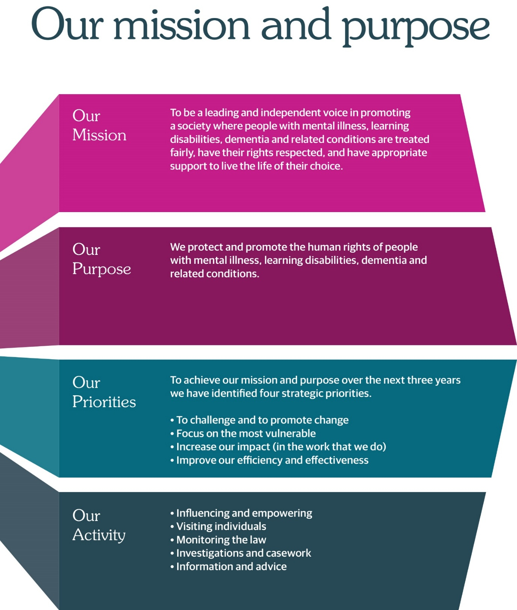

JOB ADVERT

Job title: Finance Manager
Hours: Part or full time subject to minimum commitment of 21 hours/3 days
per week
Salary: Up to £60,907 (full time equivalent based on 35 hours per week)
Contract: Permanent
Location: Thistle House, Edinburgh (hybrid working)
Reports to: Head of Culture & Corporate Services
Direct reports: 2 x Finance Officers (1.5 FTE)
Annual Budget: Approx. £7m

The Mental Welfare Commission for Scotland is recruiting an experienced and motivated Finance Manager to lead our finance function and play a key role in supporting our mission to protect and promote the human rights of people with mental illness, learning disabilities, dementia and related conditions.

As an independent statutory body, we ensure that care, treatment and support across Scotland are lawful, ethical and person centred. This is an exciting opportunity to join a values driven organisation with a strong public service ethos.

About the Role

The Finance Manager is the most senior finance professional within the Commission, responsible for delivering robust financial management, statutory compliance, payroll oversight, and strategic financial advice. You will oversee an annual budget of approximately £7m and act as the organisation’s subject matter expert for all financial matters.

Working closely with the Head of Culture & Corporate Services, you will lead on:

• Financial reporting, analysis and advice to the CEO, executive leadership team and the Board
• Annual budget setting and multi-year forecasting
• Year-end accounts and external/internal audit
• Payroll and the annual pay award process in line with Scottish Government Pay Policy
• Financial controls, policies, procedures and risk management
• Procurement compliance and value for money
• Managing the shared services arrangement with Scottish Government (Oracle)

This role offers significant autonomy, influence and the opportunity to shape financial stewardship across the organisation.

About You

We are looking for someone who brings:

• A professional accountancy qualification (ACCA, CIMA, ICAS or equivalent)
• Significant experience in public sector financial management
• Strong knowledge of the Scottish Public Finance Manual (SPFM) and Scottish Government Pay Policy
• Experience managing payroll and related processes
• Excellent analytical, communication and influencing skills
• The ability to work independently across a wide remit
• A commitment to public sector values, integrity and continuous improvement
• People management experience and familiarity with Scottish Government shared services (Oracle) is desirable.

What We Offer

• Flexibility on contracted hours, subject to a minimum commitment of 21 hours/3 days per week (0.6 FTE).
• Hybrid working
• Modern open plan office and facilities in the centre of Edinburgh
• Generous annual leave and NHS pension
• Supportive, inclusive organisational culture
• Opportunities for professional development
• A meaningful role contributing to human rights and public service in Scotland
• An organisation which is keen to continue to adapt and transform to meet the needs of the people it serves

If you wish to view more information on applying, please visit our website:
Work with us | Mental Welfare Commission for Scotland (mwcscot.org.uk)

How to Apply

Application forms should be submitted to mwc.recruitment@nhs.scot by Friday 28 August 2026 at midday.

JOB DESCRIPTION

Job title: Finance Manager
Hours: Part or full time subject to minimum commitment of 21 hours/3 days
per week
Salary: Up to £60,907 (full time equivalent based on 35 hours per week)
Location: Thistle House, Edinburgh (hybrid working)
Reports to: Head of Culture & Corporate Services
Direct reports: 2 x Finance Officers (1.5 FTE)
Annual Budget: Approx. £7m

1 | Job Purpose
 | The Finance Manager is the most senior finance professional within the Commission, responsible for delivering robust financial management, statutory compliance, payroll oversight, and strategic financial advice.
2 | Role of the Mental Welfare Commission
 | The Mental Welfare Commission for Scotland (the Commission) protects and promotes the human rights of people with mental illness, learning disabilities, dementia and related conditions. As an independent statutory body, we ensure that care, treatment and support are lawful, ethical and person-centered.
3 | Key result areas – Summary
Financial Management & Reporting

- Provide financial analysis and advice to the CEO, executive leadership team and the Board.
- Monitor and report on financial performance to the executive leadership team and to Scottish Government.
- Prepare year-end accounts and all supporting documentation for external audit.
- Attend and present at the Audit, Performance & Risk Committee.
- Ensure compliance with the Scottish Public Finance Manual (SPFM).
- Ensure action plans from audit reports are disseminated and actions are addressed ensuring compliance with best practice.

Budgeting & Forecasting

- Lead the annual budget planning process.
- Develop multi-year financial forecasts.
- Provide monthly actual and projected budget reporting across all main budget categories to the CEO, to Scottish Government and to Project Leads

Payroll, Pay Policy & Remuneration

- Manage end-to-end payroll for all salaried and fee paid staff (jointly with the People & Organisational Development Team).
- Lead the annual pay remit process in line with Scottish Government Pay Policy, prepare and submit all relevant returns to the Pay Policy unit
- Advise staff on any pay and reward matters

Financial Controls, Governance & Procedures

- Maintain and annually review all financial controls, policies and procedures ensuring in line with current legislation, best practice and the SPFM
- Oversee ledgers, reconciliations, accounts payable/receivable, and expenses.
- Liaise regularly with Scottish Government colleagues to ensure compliance with all Oracle related procedures
- Ensure procurement compliance and value for money.
- Manage financial risk.

Strategic Contribution

- Act as senior financial adviser and subject matter expert.
- Contribute to business cases and strategic projects.

Shared Services & Systems

- Manage the shared services arrangement with Scottish Government (Oracle).
- Ensure accurate and timely processing of transactions within SG prescribed timelines

Leadership & Team Management

- Member of the Extended Leadership Team.
- Line manage the Finance Officers.
- Promote continuous improvement and strong financial stewardship.

4. Person Specification – Qualifications, Skills & Knowledge

Essential

- Professional accountancy qualification (ACCA, CIMA, ICAS) or equivalent.
- Significant experience in public-sector financial management.
- Strong understanding of Scottish Public Finance Manual and Scottish Government Pay Policy.
- Experience and sound working knowledge of managing payroll and related processes.
- Excellent analytical and communication skills.
- Ability to work largely unsupervised across a wide remit.
- People management experience.

Desirable

- Experience with Scottish Government shared services (Oracle).
- Improving financial systems.
- Procurement experience.
PERSON SPECIFICATION

Qualifications

Essential
- Professional accountancy qualification (e.g., ACCA, CIMA, ICAS) or equivalent.

Desirable
- Evidence of continuing professional development in public sector finance, audit, or governance.

Experience

Essential
- Significant experience in public sector financial management, including budget setting, monitoring, and reporting.
- Preparing year end accounts and supporting internal and external audit processes.
- Managing payroll and leading the pay award process in line with Scottish Government Pay Policy.
- Overseeing financial controls, reconciliations, ledgers, accounts payable/receivable, and expenses.
- Providing financial advice to senior leaders and contributing to organisational decision making.
- Working largely unsupervised across a wide remit, acting as the organisation’s senior financial adviser.
- People management experience.

Desirable
- Working with Scottish Government shared services, including Oracle.
- Contributing to business cases, funding bids, or strategic projects.
- Improving or developing financial systems or processes.
- Knowledge of public sector procurement requirements and value for money principles.

Knowledge

Essential
- Strong understanding of the Scottish Public Finance Manual (SPFM) and its application.
- Solid understanding of Scottish Government Pay Policy and public sector remuneration processes.

Desirable
- Understanding of financial risk management and internal control frameworks.

Skills & Abilities

Essential
- Excellent analytical skills, with the ability to interpret complex financial information and present it clearly to non-finance colleagues.
- Strong communication skills, both written and verbal, with the ability to influence and advise senior stakeholders.
- Ability to produce accurate, timely financial reports and forecasts.
- Ability to manage competing priorities and work independently with minimal supervision.
- Strong organisational skills and attention to detail.
- Ability to build effective working relationships across teams and with external partners (e.g., Scottish Government shared services).

Desirable
- Ability to identify and implement improvements to financial systems, processes, or reporting.

JOB INFORMATION

Headquarters | Thistle House, 91 Haymarket Terrace, Edinburgh, EH12 5HE (hybrid working options)
Leave | Annual Holidays  The annual entitlement for full time posts is 25 days per year, rising to 30 days after 10 years’ relevant service. (NHS and local authority service is counted as relevant service). Leave entitlement is pro-rata for part-time posts.  General/Public Holidays  Public and privilege holidays total 11.5 days per leave year, 6 of these are on set dates and the remainder can be taken as required.  For part time posts, the public/privilege holiday entitlement is pro-rata to full time equivalent.  The leave year runs from 1st April to 31st March.
Superannuation | NHS Pension Scheme is available to all employees subject to scheme rules.  Please click here for current contributions details.  The employer currently contributes an amount equal to 20.9% of pensionable pay into the scheme on members’ behalf.
Staff Benefits | Through the Commission employee Benefits scheme there is access to a wide variety of offers and discounts from the UK’s most popular retailers and service providers. The current provider is EdenRed. There is also access to, My Gyms discount site, the UK's largest network of gyms, studios, fitness centres and sports clubs across the UK with discounted membership offers. A comprehensive Employee Assistance Programme is also available and access to a Cycle to Work Scheme. (The Commission reserves the right to withdraw, amend the schemes and change providers as appropriate)
Our values | The Commission operates a set of internal values for employees.
Performance, Learning and Development | There is a performance development system in operation within the Commission. Progression through the salary scale is subject to satisfactory performance.
Data protection | The information you provide on the application form and any supplementary forms will be used to assist in the process of recruitment and selection in accordance with the Policy of the Mental Welfare Commission.  If you are successful in your application the information you provide will be used for HR and Payroll purposes. By signing the declaration section of the application form it is understood that you consent to the use and storage of your personal information for the above stated purposes.
Work outside the Commission | It is important to identify and minimise any conflicts of interest that could prevent staff from making fair and objective judgements or could be perceived as doing so by people with lived experience and carers, practitioners and the public. Details are contained in the Commission’s Conflict of Interest Policy. Please note that employees may not be members or employees of the Mental Health Tribunal for Scotland while working for the Commission.
Probationary period | The post requires a 3 months’ probationary period.
Disclosure Scotland | The post requires a Level 2 Disclosure Scotland check.
Occupational Health Screening | Any offer of employment is subject to satisfactory Occupational Health clearance. The successful candidate will be asked to complete a Pre-Employment Health Questionnaire. NHS Lothian Occupational Health will make an assessment on your fitness to carry out the post based on the information contained within the questionnaire. In certain circumstances further information is required before clearance can be given and Occupational Health may contact you by telephone or request that you attend for an appointment. Clearance must be obtained before any new employee commences employment. Clearance may be subject to you attending for a post-Employment appointment and it is vital that you attend this appointment if required.
Complaints | The Commission has a Complaints Handling Procedure. All applicants have access to it if they feel they have been unfairly treated during the recruitment and selection process. External applicants should direct any concerns to the Human Resources department and internal applicants have recourse to the Commission’s Grievance Procedure.
Equal opportunities | The Commission is an equal opportunities employer.
Feedback | We do recognise the time and effort it takes to apply for a position. Following the short-listing process, you will be notified about the outcome of your application by email.

