
Finance Manager
June 2026
Job Pack

Contents
Advert
Job Description
Person Specification
Employment Information
How to Apply

Foreword
Thank you for your interest in this post and in the Mental Welfare Commission (the Commission).
Our Mission is to be a leading and independent voice in promoting a society where people with mental illness, learning disabilities, dementia and related conditions are treated fairly, have their rights respected, and have appropriate support to live the life of their choice.
It is an exciting time to join the Commission to contribute to our strategic priorities, challenging and promoting change, focusing on the most vulnerable, increasing our impact and improving our efficiency and effectiveness.
This is an opportunity to contribute your experience to supporting the Commission to make a difference to individual’s lives in an independent, national organisation focussing on the rights of individuals across Scotland. Our recent reports on monitoring mental health and incapacity legislation and our themed visits highlight the work that you will be involved in.

For further information on our organisation, please click on our web-link.
Our modern office is based in central Edinburgh, very close to Haymarket Railway station and is served with very good public transport links across Scotland. As an organisation, we work Scotland wide and serve different regions within our teams.
We offer:
- a comprehensive range of HR policies including policies to help balance commitments at work and home and flexible family friendly working arrangements
- training and development opportunities
- access to occupational health services
- access to an employee assistance programme
- access to employee benefits/employee discounts
- a cycle to work scheme
- access to the NHS pension scheme

The following information will help you with your application:
- recruitment advertisement
- job description
- person specification
- terms and conditions of employment information sheet

We hope you are encouraged to apply and look forward to receiving your application.

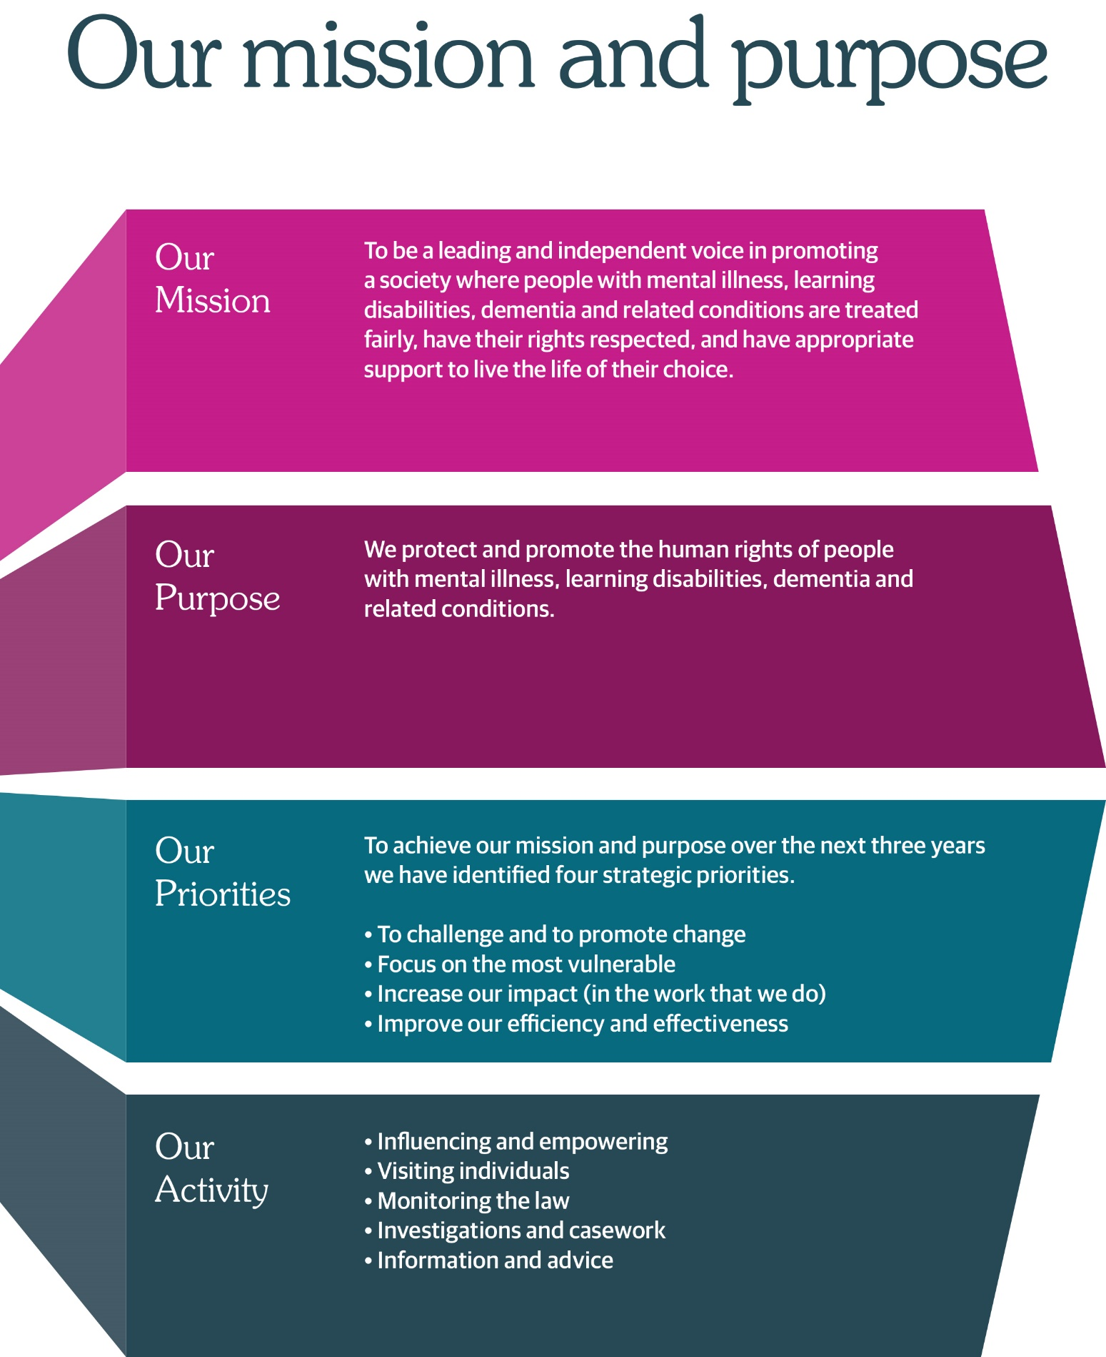

Job title: Finance Manager
Hours: Permanent, 28 hours per week (0.8 FTE)
Salary: £54,816 – £60,907 (£43,852 – £48,725 pro rata)
Location: Thistle House, Edinburgh (hybrid working)
Reports to: Head of Culture & Corporate Services
Direct reports: 1 x Finance Officer (1 FTE, increasing to 1.5 FTE)
Annual Budget
Responsibility: Approx. £7m

Finance Manager
The Mental Welfare Commission for Scotland is recruiting an experienced and motivated Finance Manager to lead our finance function and play a key role in supporting our mission to protect and promote the human rights of people with mental illness, learning disabilities, dementia and related conditions.

As an independent statutory body, we ensure that care, treatment and support across Scotland are lawful, ethical and person centred. This is an exciting opportunity to join a values driven organisation with a strong public service ethos.

About the Role
The Finance Manager is the most senior finance professional within the Commission, responsible for delivering robust financial management, statutory compliance, payroll oversight, and strategic financial advice. You will oversee an annual budget of approximately £7m and act as the organisation’s subject matter expert for all financial matters.

Working closely with the Head of Culture & Corporate Services, you will lead on:
• Financial reporting, analysis and advice to the CEO, executive leadership team and the Board
• Annual budget setting and multi-year forecasting
• Year-end accounts and external/internal audit
• Payroll and the annual pay award process in line with Scottish Government Pay Policy
• Financial controls, policies, procedures and risk management
• Procurement compliance and value for money
• Managing the shared services arrangement with Scottish Government (Oracle)

This role offers significant autonomy, influence and the opportunity to shape financial stewardship across the organisation.

About You
We are looking for someone who brings:
• A professional accountancy qualification (ACCA, CIMA, ICAS or equivalent)
• Significant experience in public sector financial management
• Strong knowledge of the Scottish Public Finance Manual (SPFM) and Scottish Government
Pay Policy
• Experience managing payroll and related processes
• Excellent analytical, communication and influencing skills
• The ability to work independently across a wide remit
• A commitment to public sector values, integrity and continuous improvement
• People management experience and familiarity with Scottish Government shared services (Oracle) is desirable.
What We Offer
• Hybrid working
• Modern open plan office and facilities in the centre of Edinburgh
• Generous annual leave and NHS pension
• Supportive, inclusive organisational culture
• Opportunities for professional development
• A meaningful role contributing to human rights and public service in Scotland
• An organisation which is keen to continue to adapt and transform to meet the needs of the people it serves

If you wish to view more information on applying, please visit our website:
Work with us | Mental Welfare Commission for Scotland (mwcscot.org.uk)

How to Apply
Full details, including the job description and person specification, are available in the recruitment pack.

Applications should be submitted in line with the instructions provided by 14th July 2026 at midday. It is anticipated that interviews will take place week commencing 23 July 2026 at our office in Edinburgh.

Job title: Finance Manager
Hours: Permanent, 28 hours per week (0.8 FTE)
Salary: £54,816 – £60,907 (£43,852 – £48,725 pro rata)
Location: Thistle House, Edinburgh (hybrid working)
Reports to: Head of Culture & Corporate Services
Direct reports: 1 x Finance Officer (1 FTE, increasing to 1.5 FTE)
Annual Budget
Responsibility: Approx. £7m
Job Description
1 | Job Purpose
 | The Finance Manager is the most senior finance professional within the Commission, responsible for delivering robust financial management, statutory compliance, payroll oversight, and strategic financial advice.
2 | Role of the Mental Welfare Commission
The Mental Welfare Commission for Scotland is an independent statutory body. We protect and promote the human rights of people with mental illness, learning disabilities, dementia and related conditions.
We do this through visiting, monitoring, investigation and influencing policy and practice. Our work is grounded in the principles of the Mental Health (Care and Treatment) (Scotland) Act 2003 and the Adults with Incapacity (Scotland) Act 2000, alongside wider human rights frameworks
We protect and promote the human rights of people with mental illness, learning disabilities, dementia, and related conditions.
We do this by:
- Checking if individual care and treatment is lawful and in line with good practice.
- Empowering individuals and their carers through advice, guidance, and information.
- Promoting best practice in applying mental health and incapacity law.
- Influencing legislation, policy, and service development.

3 | Key result areas - Summary
Financial Management & Reporting
Provide financial analysis and advice to the CEO, executive leadership team and the Board.
Monitor and report on financial performance to the executive leadership team and to Scottish Government.
Prepare year‑end accounts and all supporting documentation for external audit.
Attend and present at the Audit, Performance & Risk Committee.
Ensure compliance with the Scottish Public Finance Manual (SPFM).
Ensure action plans from audit reports are disseminated and actions are addressed ensuring compliance with best practice.

Budgeting & Forecasting
Lead the annual budget planning process.
Develop multi‑year financial forecasts.
Provide monthly actual and projected budget reporting across all main budget categories to the CEO, to Scottish Government and to Project Leads

Payroll, Pay Policy & Remuneration
Manage end‑to‑end payroll for all salaried and fee paid staff (jointly with the People & Organisational Development Team).
Lead the annual pay remit process in line with Scottish Government Pay Policy, prepare and submit all relevant returns to the Pay Policy unit
Advise staff on any pay and reward matters

Financial Controls, Governance & Procedures
Maintain and annually review all financial controls, policies and procedures ensuring in line
with current legislation, best practice and the SPFM
Oversee ledgers, reconciliations, accounts payable/receivable, and expenses. Liaise regularly
with Scottish Government colleagues to ensure compliance with all Oracle related procedures
Ensure procurement compliance and value for money.
Manage financial risk.

Strategic Contribution
Act as senior financial adviser and subject matter expert.
Contribute to business cases and strategic projects.
Shared Services & Systems
Manage the shared services arrangement with Scottish Government (Oracle).
Ensure accurate and timely processing of transactions within SG prescribed timelines
Leadership & Team Management. Member of the Extended Leadership Team.
Line manage the Finance Officers.
Promote continuous improvement and strong financial stewardship.
4. Person Specification – Qualifications, Skills & Knowledge
Essential
Professional accountancy qualification (ACCA, CIMA, ICAS) or equivalent.
Significant experience in public‑sector financial management.
Strong understanding of Scottish Public Finance Manual and Scottish Government Pay Policy.
Experience and sound working knowledge of managing payroll and related processes.
Excellent analytical and communication skills.
Ability to work largely unsupervised across a wide remit.
People management experience.
Desirable
Experience with Scottish Government shared services (Oracle).
Improving financial systems.
Procurement experience.
Qualifications
Essential
Professional accountancy qualification (e.g., ACCA, CIMA, ICAS) or equivalent.
Desirable
Evidence of continuing professional development in public sector finance, audit, or governance.
Experience
Essential
Significant experience in public sector financial management, including budget setting, monitoring, and reporting.
Preparing year end accounts and supporting internal and external audit processes.
Managing payroll and leading the pay award process in line with Scottish Government Pay Policy.
Overseeing financial controls, reconciliations, ledgers, accounts payable/receivable, and expenses.
Providing financial advice to senior leaders and contributing to organisational decision making.
Working largely unsupervised across a wide remit, acting as the organisation’s senior financial adviser.
People management experience.
Desirable
Working with Scottish Government shared services, including Oracle.
Contributing to business cases, funding bids, or strategic projects.
Improving or developing financial systems or processes.
Knowledge of public sector procurement requirements and value for money principles.
Knowledge
Essential
Strong understanding of the Scottish Public Finance Manual (SPFM) and its application.
Solid understanding of Scottish Government Pay Policy and public sector remuneration processes.
Desirable
Understanding of financial risk management and internal control frameworks.

Skills & Abilities
Essential
Excellent analytical skills, with the ability to interpret complex financial information and present it clearly to non-finance colleagues.
Strong communication skills, both written and verbal, with the ability to influence and advise senior stakeholders.
Ability to produce accurate, timely financial reports and forecasts.
Ability to manage competing priorities and work independently with minimal supervision.
Strong organisational skills and attention to detail.
Ability to build effective working relationships across teams and with external partners (e.g., Scottish Government shared services).
Desirable
Ability to identify and implement improvements to financial systems, processes, or reporting.
Values and Approach

The post holder will be expected to:

Always uphold the human rights and dignity of individuals
Work with independence, integrity and professional curiosity
Approach investigations with fairness, objectivity and rigour
Engage constructively with stakeholders, including where findings are challenging

Job Information
Headquarters | Thistle House, 91 Haymarket Terrace, Edinburgh, EH12 5HE (hybrid working options)
Leave | Annual Holidays  The annual entitlement for full time posts is 25 days per year, rising to 30 days after 10 years’ relevant service. (NHS and local authority service is counted as relevant service). Leave entitlement is pro-rata for part-time posts.  General/Public Holidays  Public and privilege holidays total 11.5 days per leave year, 6 of these are on set dates and the remainder can be taken as required.  For part time posts, the public/privilege holiday entitlement is pro-rata to full time equivalent.  The leave year runs from 1st April to 31st March.
Superannuation | NHS Pension Scheme is available to all employees subject to scheme rules.  Please click here for current contributions details.  The employer currently contributes an amount equal to 20.9% of pensionable pay into the scheme on members’ behalf.
Staff Benefits | Through the Commission employee Benefits scheme there is access to a wide variety of offers and discounts from the UK’s most popular retailers and service providers. The current provider is EdenRed. There is also access to, My Gyms discount site, the UK's largest network of gyms, studios, fitness centres and sports clubs across the UK with discounted membership offers. A comprehensive Employee Assistance Programme is also available and access to a Cycle to Work Scheme. (The Commission reserves the right to withdraw, amend the schemes and change providers as appropriate)
Our values | The Commission operates a set of internal values for employees.
Performance, Learning and Development | There is a performance development system in operation within the Commission. Progression through the salary scale is subject to satisfactory performance.
Data protection | The information you provide on the application form and any supplementary forms will be used to assist in the process of recruitment and selection in accordance with the Policy of the Mental Welfare Commission.  If you are successful in your application the information you provide will be used for HR and Payroll purposes. By signing the declaration section of the application form it is understood that you consent to the use and storage of your personal information for the above stated purposes.
Work outside the Commission | It is important to identify and minimise any conflicts of interest that could prevent staff from making fair and objective judgements or could be perceived as doing so by people with lived experience and carers, practitioners and the public. Details are contained in the Commission’s Conflict of Interest Policy. Please note that employees may not be members or employees of the Mental Health Tribunal for Scotland while working for the Commission.
Probationary period | The post requires a 3 months’ probationary period.
Disclosure Scotland | The post requires a Disclosure Scotland Basic certificate and self-declaration.
Occupational Health Screening | Any offer of employment is subject to satisfactory Occupational Health clearance. The successful candidate will be asked to complete a Pre-Employment Health Questionnaire. NHS Lothian Occupational Health will make an assessment on your fitness to carry out the post based on the information contained within the questionnaire. In certain circumstances further information is required before clearance can be given and Occupational Health may contact you by telephone or request that you attend for an appointment. Clearance must be obtained before any new employee commences employment. Clearance may be subject to you attending for a post-Employment appointment and it is vital that you attend this appointment if required.
Complaints | The Commission has a Complaints Handling Procedure. All applicants have access to it if they feel they have been unfairly treated during the recruitment and selection process. External applicants should direct any concerns to the Human Resources department and internal applicants have recourse to the Commission’s Grievance Procedure.
Equal opportunities | The Commission is an equal opportunities employer.
Feedback | We do recognise the time and effort it takes to apply for a position. Following the short-listing process, you will be notified about the outcome of your application by email.

How to Apply
The Mental Welfare Commission encourages applications from all sections of the community.

We aim to have a workforce which represents the wider society that we serve and therefore encourage applications from people of all backgrounds and under-represented groups.

We hope the information we have provided will encourage you to find out more about this opportunity.

If you wish to view more information on applying, please visit our website:
Work with us | Mental Welfare Commission for Scotland (mwcscot.org.uk)

How to Apply
Full details, including the job description and person specification, are available in the recruitment pack.

Applications should be submitted in line with the instructions provided by 14th July 2026 at midday. It is anticipated that interviews will take place week commencing 23 July 2026 at our office in Edinburgh.

