
Consultant Psychiatrist - Investigations
June 2026
Job Pack

Contents
Advert
Job Description
Person Specification
Employment Information
How to Apply

Foreword
Thank you for your interest in this post and in the Mental Welfare Commission (the Commission).
Our Mission is to be a leading and independent voice in promoting a society where people with mental illness, learning disabilities, dementia and related conditions are treated fairly, have their rights respected, and have appropriate support to live the life of their choice.
It is an exciting time to join the Commission to contribute to our strategic priorities, challenging and promoting change, focusing on the most vulnerable, increasing our impact and improving our efficiency and effectiveness.
This is an opportunity to contribute your experience to supporting the Commission to make a difference to individual’s lives in an independent, national organisation focussing on the rights of individuals across Scotland. Our recent reports on monitoring mental health and incapacity legislation and our themed visits highlight the work that you will be involved in.

For further information on our organisation, please click on our web-link.
Our modern office is based in central Edinburgh, very close to Haymarket Railway station and is served with very good public transport links across Scotland. As an organisation, we work Scotland wide and serve different regions within our teams.
We offer:
- a comprehensive range of HR policies including policies to help balance commitments at work and home and flexible family friendly working arrangements
- training and development opportunities
- access to occupational health services
- access to an employee assistance programme
- access to staff benefits/staff discounts
- a cycle to work scheme
- access to the NHS pension scheme

The following information will help you with your application:
- recruitment advertisement
- job description
- person specification
- terms and conditions of employment information sheet

We hope you are encouraged to apply and look forward to receiving your application.

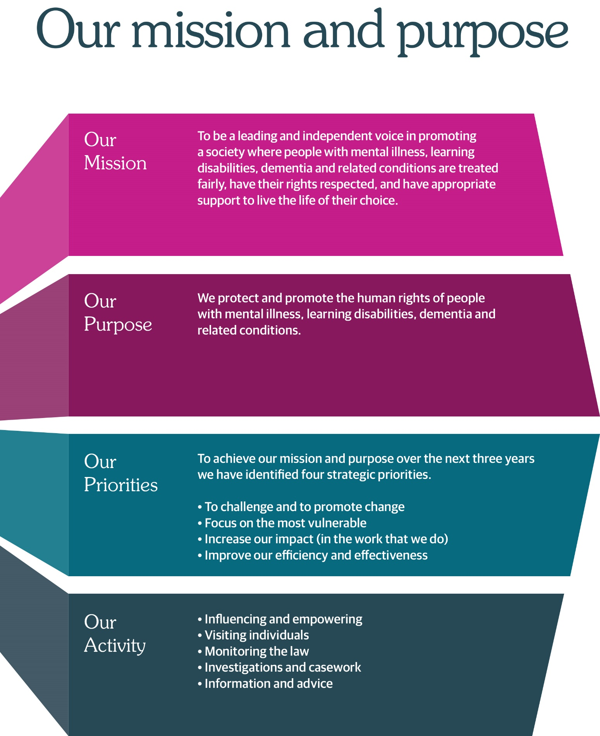

Job Advert
Job Title: Consultant Psychiatrist – Investigations
Hours: 0.5 WTE (5 sessions; typically, 2.5 days per week)
Location: Thistle House, Edinburgh (hybrid working)
Salary: NHS Consultant scale (pro rata)
Accountable to: Executive Director (Social Work) – operationally
Executive Director (Medical) – professionally
Responsible to: Chief Executive

About Us
The Mental Welfare Commission for Scotland is an independent statutory body. Our mission is to promote a society where people with mental illness, learning disabilities, dementia, and related conditions are treated fairly, have their rights respected, and receive the support they need to live the life of their choice.
Our work is both challenging and highly rewarding. Colleagues across the Commission play a vital role in protecting the rights and welfare of some of Scotland’s most vulnerable people. Success in this role requires strong professional judgement, excellent communication skills, and a collaborative approach.
We are seeking an experienced and motivated Consultant Psychiatrist to support our investigations work. You will contribute your significant medical expertise across the Commission’s investigation function and support the wider Commission to deliver its strategic and business objectives, helping to ensure high standards of care, accountability, and respect for human rights across mental health and social care services.
This is a unique opportunity to apply your clinical expertise in a national, system-wide role with real impact on policy and practice in Scotland.

Further Information and Application
Applications should be submitted by email to mwc.recruitment@nhs.scot by 29 July 2026.
Interview date: Interviews are expected to take place week commencing 10th August 2026 at our Edinburgh office.

Candidate Information Pack
Consultant Psychiatrist – Investigations
Mental Welfare Commission for Scotland

Salary: NHS Consultant scale (pro rata)
Hours: 0.5 WTE (5 sessions; typically, 2.5 days per week)

Location: Thistle House, Edinburgh (hybrid working)
Contract: Permanent

Accountable to: Executive Director (Social Work) operationally.

Executive Director (Medical) professionally.

Responsible to: Chief Executive
1. About the Mental Welfare Commission for Scotland
The Mental Welfare Commission for Scotland is an independent statutory body established to protect and promote the human rights, welfare, and dignity of people with mental illness, learning disabilities, dementia, and related conditions. We ensure that care, treatment, and support are lawful, ethical, and aligned with the principles of human rights and equality.
Our work includes:
- Monitoring the operation of mental health and incapacity legislation
- Visiting individuals in care settings
- Undertaking investigations and inquiries
- Providing advice and guidance to professionals and the public
- Influencing national policy and legislation
- Publishing research, reports, and good practice guidance
We operate independently of government, enabling us to speak with authority and impartiality on matters affecting some of Scotland’s most vulnerable people.

2. The Role: Consultant Psychaitrist (Investigations)
The Consultant Psychiatrist will provide medical advice to the Commission across all its functions and will support the Commission in achieving its strategic aims and objectives; in particular this role will be the key medical role for the Commission’s investigative work in relation to serious concerns about care and treatment.
This includes involvement with individual cases, adverse events, and systemic issues within mental health and incapacity services. The post holder will provide senior clinical, legal and analytical expertise to ensure that investigations are robust, rights-based, and produce authoritative findings and recommendations.
Flexibility is required to meet the demands of investigative work, including attendance at interviews, visits and stakeholder meetings. Some travel within Scotland will be required.
3. Key Responsibilities

Investigations
- Lead and contribute to investigations commissioned by the Commission, including complex, high-risk and high-profile case

- Undertake detailed review of clinical records, decision-making processes and systems of care

- Analyse practice against statutory requirements, professional standards and human rights frameworks

- Evaluate conflicting accounts and evidence to reach balanced, defensible conclusions

- Conduct investigative interviews with individuals, families, clinicians and other stakeholders

- Participate in or lead investigative visits as required

Reporting
- Produce high-quality written reports with clear findings, structured analysis and evidence-based recommendations
- Ensure reports are suitable for external scrutiny, including by Parliament, regulators, or the courts
- Contribute to thematic and national reports arising from investigative work
- Support dissemination of learning to improve practice across Scotland

Professional and Clinical Leadership
- Provide expert clinical advice within investigations and across the Commission’s functions, including in relation to the operation of part 16 safeguards under the Mental Health (Care and Treatment) (Scotland) Act.

- Support multidisciplinary investigative teams, including practitioners from nursing, social work and other multidisciplinary backgrounds

- Contribute to the development of investigative methodologies and standards within the Commission

- Maintain awareness of developments in mental health law, policy and clinical practice

Stakeholder Engagement
- Engage with individuals and families in a sensitive and professional manner

- Liaise with NHS Boards, health and social care partnerships, local authorities and other partner organisations.

- Represent the Commission in meetings and discussions relating to investigations and other Commission functions, as required.

- Contribute to external engagement, including presentations and professional dialogue

Organisational Contribution
- Contribute to the Commission’s wider work, including telephone advice, visits, monitoring and policy development where relevant

- Support the integration of learning from investigations into national monitoring activity, including restrictive practices work

- Participate in internal governance processes as required

4. Person Specification

Essential
- Fully registered medical practitioner with the General Medical Council
- On the Specialist Register in Psychiatry
- MRCPsych or equivalent
- Substantial experience at consultant level

- Demonstrable experience of working as a collegiate member of a multidisciplinary team.

- Demonstrable experience of complex case analysis, serious incident review/ investigative work

- Strong analytical skills with the ability to evaluate complex and conflicting evidence

- Experience of producing high-quality written reports for external audiences

- Sound knowledge of the Mental Health (Care and Treatment) (Scotland) Act 2003 and the Adults with Incapacity (Scotland) Act 2000

- Understanding of human rights frameworks relevant to mental health and incapacity

- Commitment to human rights, equality, and ethical practice.

- Ability to exercise independent professional judgement in sensitive and complex situations
- Excellent communication skills, both written and verbal

5. Desirable
- Experience of working in forensic psychiatry, complex care, or high-risk clinical settings
- Experience of working with regulatory, inspection or investigatory bodies
- Knowledge of Scottish public sector governance and accountability structures
- Experience of contributing to national policy or service improvement

Professional Requirements
The post holder will be expected to:
– Maintain full GMC registration and licence to practise
– Participate in annual medical appraisal and revalidation
– Undertake continuing professional development relevant to the role

Values and Approach
The post holder will be expected to:
– Uphold the human rights and dignity of individuals at all times
– Work with independence, integrity and professional curiosity
– Approach investigations with fairness, objectivity and rigour
– Engage constructively with stakeholders, including where findings are challenging
6. Working at the Commission
Hybrid Working
The Commission operates a hybrid working model. The postholder will be expected to attend the Edinburgh office regularly, with flexibility depending on business needs. Some evening/unsociable hours will be required from time to time.
Benefits
- Generous annual leave entitlement
- Membership of the NHS pension scheme
- Flexible working arrangements
- Commitment to professional development
- Supportive, values-driven organisational culture
7. Recruitment Process
The selection process is likely to include:
- Application form
- Shortlisting against essential criteria
- Assessment of independent clinical judgement through application of legislation, policy and standards (e.g. case study or scenario)
- Presentation & competency-based interview
- References and pre-employment checks
8. How to Apply
Candidates will be asked to submit:
- Application form to include details of how they meet the essential criteria
Applications should be submitted by email to mwc.recruitment@nhs.scot by 29th July 2026.

9. Further Information
Informal enquiries may be directed to the Executive Director Medical and/or the Executive Director Social Work (contact via Executive Officer Fiona Hamilton – Fiona.hamilton8@nhs.scot

10. Additional Information
This role offers an opportunity to contribute to the Commission’s increasing focus on systemic investigations and national oversight, including work to reduce restrictive practices and improve care quality across Scotland.

Headquarters | Thistle House, 91 Haymarket Terrace, Edinburgh, EH12 5HE (hybrid working options)
Leave | Annual Holidays  The annual entitlement for full time posts is 25 days per year, rising to 30 days after 10 years’ relevant service. (NHS and local authority service is counted as relevant service). Leave entitlement is pro-rata for part-time posts.  General/Public Holidays  Public and privilege holidays total 11.5 days per leave year, 6 of these are on set dates and the remainder can be taken as required.  For part time posts, the public/privilege holiday entitlement is pro-rata to full time equivalent.  The leave year runs from 1st April to 31st March.
Superannuation | NHS Pension Scheme is available to all staff subject to scheme rules.  Please click here for current contributions details.  The employer currently contributes an amount equal to 20.9% of pensionable pay into the scheme on members’ behalf.
Staff Benefits | Through the Commission Staff Benefits scheme there is access to a wide variety of offers and discounts from the UK’s most popular retailers and service providers. The current provider is EdenRed. There is also access to, My Gyms discount site, the UK's largest network of gyms, studios, fitness centres and sports clubs across the UK with discounted membership offers. A comprehensive Employee Assistance Programme is also available and access to a Cycle to Work Scheme. (The Commission reserves the right to withdraw, amend the schemes and change providers as appropriate)
Our values | The Commission operates a set of internal values for staff.
Performance, Learning and Development | There is a performance development system in operation within the Commission. Progression through the salary scale is subject to satisfactory performance.
Data protection | The information you provide on the application form and any supplementary forms will be used to assist in the process of recruitment and selection in accordance with the Policy of the Mental Welfare Commission.  If you are successful in your application the information you provide will be used for HR and Payroll purposes. By signing the declaration section of the application form it is understood that you consent to the use and storage of your personal information for the above stated purposes.
Work outside the Commission | It is important to identify and minimise any conflicts of interest that could prevent staff from making fair and objective judgements or could be perceived as doing so by people with lived experience and carers, practitioners and the public. Details are contained in the Commission’s Conflict of Interest Policy. Please note that employees may not be members or employees of the Mental Health Tribunal for Scotland while working for the Commission.
Probationary period | The post requires a 3 months’ probationary period.
Disclosure Scotland | The post requires a Disclosure Scotland Basic certificate and self-declaration.
Occupational Health Screening | Any offer of employment is subject to satisfactory Occupational Health clearance. The successful candidate will be asked to complete a Pre-Employment Health Questionnaire. NHS Lothian Occupational Health will make an assessment on your fitness to carry out the post based on the information contained within the questionnaire. In certain circumstances further information is required before clearance can be given and Occupational Health may contact you by telephone or request that you attend for an appointment. Clearance must be obtained before any new employee commences employment. Clearance may be subject to you attending for a post-Employment appointment and it is vital that you attend this appointment if required.
Complaints | The Commission has a Complaints Handling Procedure. All applicants have access to it if they feel they have been unfairly treated during the recruitment and selection process. External applicants should direct any concerns to the Human Resources department and internal applicants have recourse to the Commission’s Grievance Procedure.
Equal opportunities | The Commission is an equal opportunities employer.
Feedback | We do recognise the time and effort it takes to apply for a position. Following the short-listing process, you will be notified about the outcome of your application by email.

