
Social Work Officer
June 2026
Job Pack

Contents
Advert
Job Description
Person Specification
Employment Information
How to Apply

Foreword
Thank you for your interest in this post and in the Mental Welfare Commission (the Commission).
Our Mission is to be a leading and independent voice in promoting a society where people with mental illness, learning disabilities, dementia and related conditions are treated fairly, have their rights respected, and have appropriate support to live the life of their choice.
It is an exciting time to join the Commission to contribute to our strategic priorities, challenging and promoting change, focusing on the most vulnerable, increasing our impact and improving our efficiency and effectiveness.
This is an opportunity to contribute your experience to supporting the Commission to make a difference to individual’s lives in an independent, national organisation focussing on the rights of individuals across Scotland. Our recent reports on monitoring mental health and incapacity legislation and our themed visits highlight the work that you will be involved in.

For further information on our organisation, please click on our web-link.
Our modern office is based in central Edinburgh, very close to Haymarket Railway station and is served with very good public transport links across Scotland. As an organisation, we work Scotland wide and serve different regions within our teams.
We offer:
- a comprehensive range of HR policies including policies to help balance commitments at work and home and flexible family friendly working arrangements
- training and development opportunities
- access to occupational health services
- access to an employee assistance programme
- access to employee benefits/staff discounts
- a cycle to work scheme
- access to the NHS pension scheme

The following information will help you with your application:
- recruitment advertisement
- job description
- person specification
- terms and conditions of employment information sheet

We hope you are encouraged to apply and look forward to receiving your application.

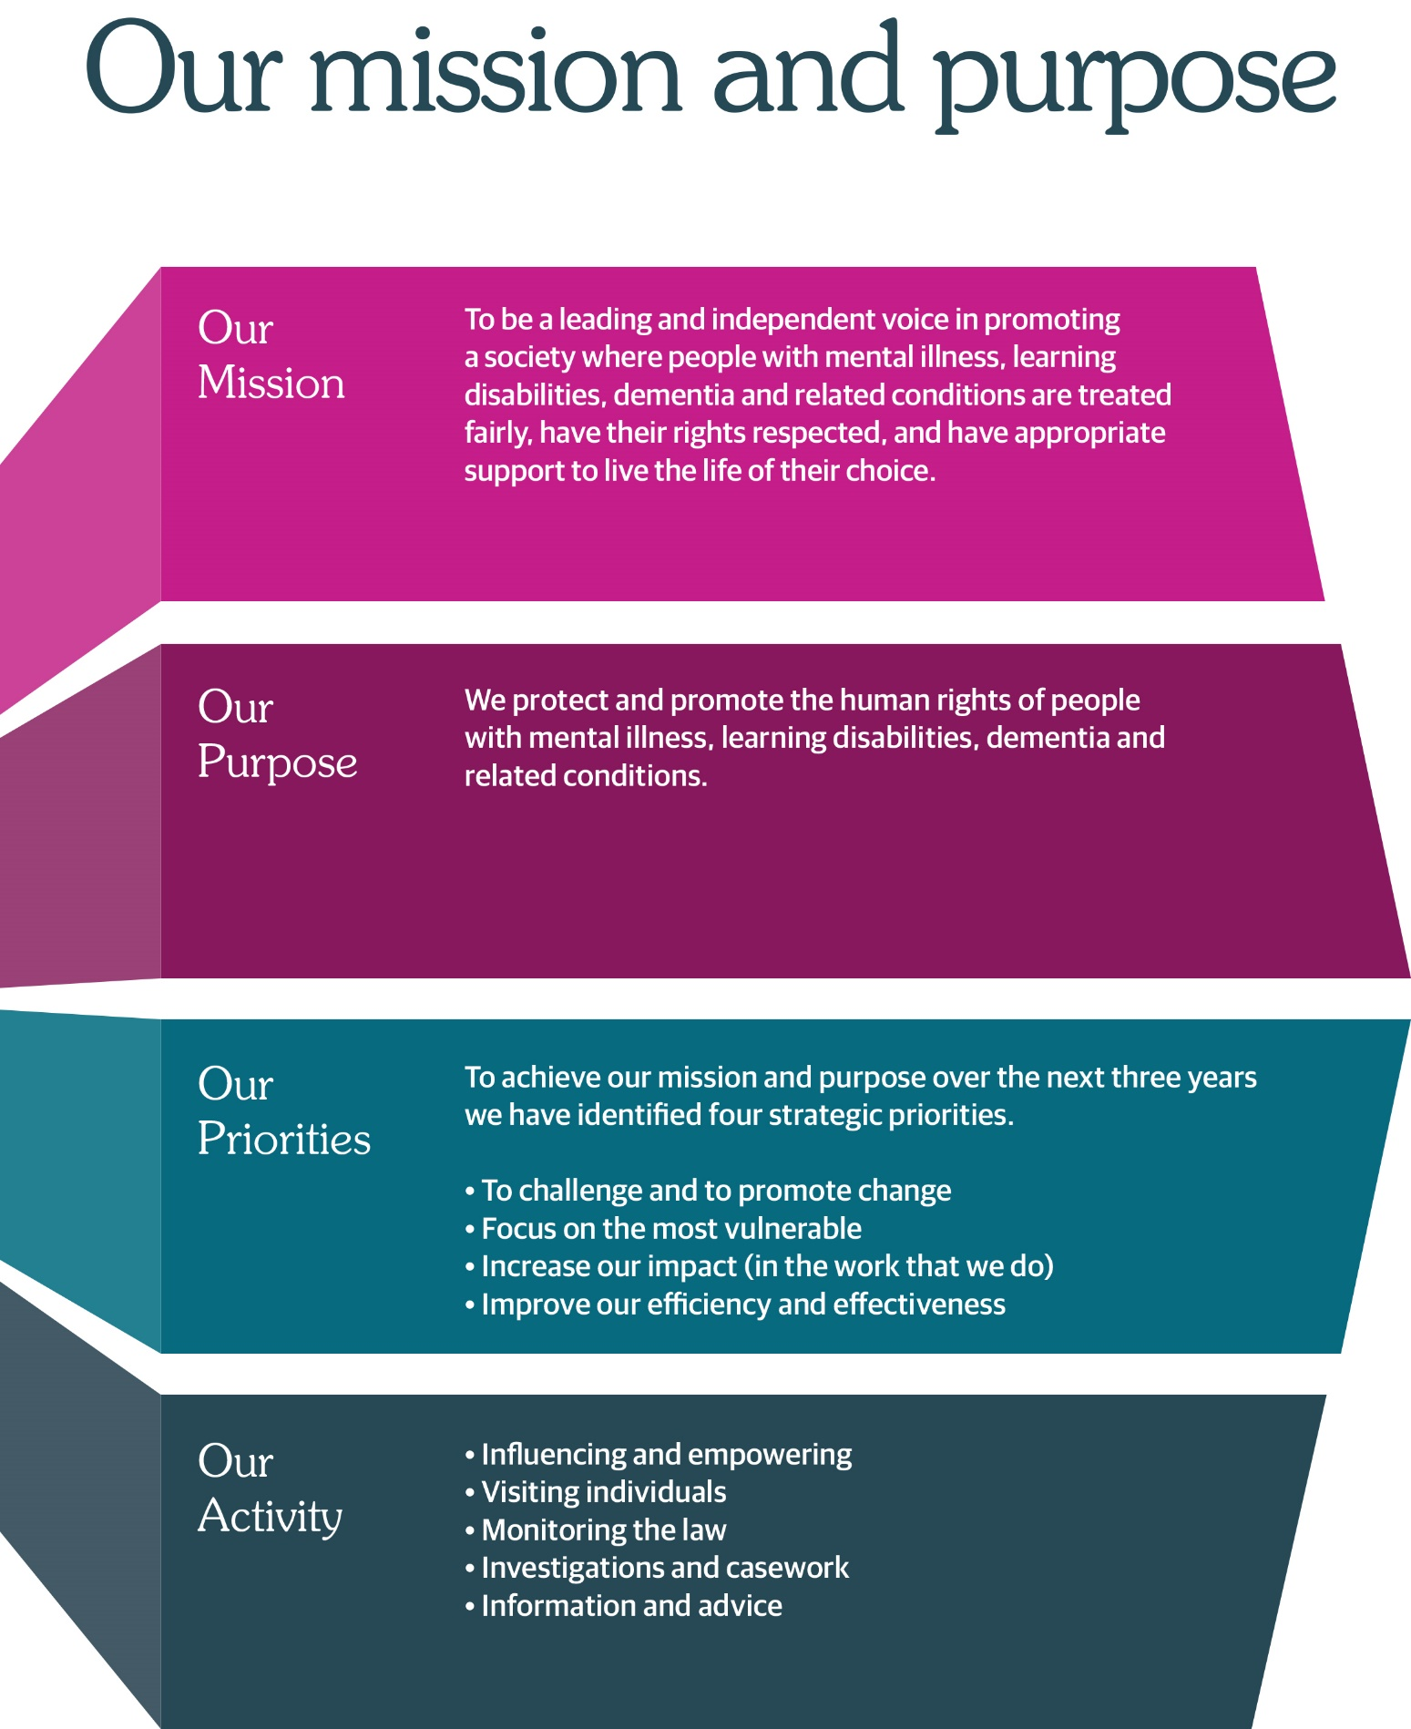

Social Work Officer
2 Opportunities

Contract One Permanent Role
One Fixed term/secondment opportunity for 12 months
Hours Full Time, 35 hours per week
Salary £65,075 - £72,306
Location Based in Edinburgh (Haymarket), hybrid working option

We protect and promote the human rights of people with mental illness, learning disabilities, dementia and related conditions.

We are currently recruiting for two posts for either experienced Social Worker Officers to join our team; these posts will support the planned work outlined in the Commission’s business and strategic plan.

The role will require the postholder to have direct contact with individuals with lived/living experience, their relatives and carers in respect of their concerns about their mental health and/or the care and treatment they receive.

Will also be required to carry out investigation work and deal with casework pertaining to an allocated area. While the role is based in Edinburgh, the postholder will be attached to a team covering a particular geographical area of Scotland and will be required to visit services across the whole of Scotland.

You must be qualified as a Social Worker Officer with the MHO award and recent experience of direct application as an MHO. In addition, you should have experience of operating at senior practitioner level and involvement in the practical application of mental health and incapacity legislation and rights-based care.

Supervisory/Management experience is also essential.

As an employer, we offer excellent terms and conditions of service including a generous pension scheme, a commitment to learning and development and access to an Employee Assistance Programme and comprehensive employee benefits.

We also offer a comprehensive range of HR policies including policies to help balance commitments at work and home and flexible working arrangements.

At the Commission we champion diversity, inclusion and wellbeing. We pride ourselves on being an employer of choice, cultivating a sense of belonging and providing a workplace where everyone feels valued. We aim to have a workforce which represents the wider society that we serve and therefore encourage applications from people of all backgrounds and under-represented groups.

Our office environment is modern, light, bright and green with superb views and is very close to Haymarket Railway station and transport links.

For more information on applying, please phone 0131 313 8783/8772 or visit the website at https://www.mwcscot.org.uk/about-us/work-us

For an informal discussion about this vacancy, please contact either Lesley Paterson, senior manager, Claire Lamza or Suzanne McGuinness, executive directors by telephoning 0131 313 8777.

Closing date for application is 12/06/2026 at 12.00pm, and interviews will take place on 24/06/2026 either in the office or via Microsoft Teams.

Job Description
Contract One Permanent Role
One Fixed term/secondment opportunity for 12 months
Hours Full Time, 35 hours per week
Salary £65,075 - £72,306 per annum
Location Based in Edinburgh (Haymarket), hybrid working option
Flexibility is required to meet the demands some travel within Scotland will be required.
Reports To: Senior Manager
Direct Reports: None
1 | Job Purpose
 | Carry out Social Work Officer responsibilities to support the Commission in achieving its strategic aims and objectives.

2 | Dimensions
This post has a Scotland wide remit. This includes influencing and negotiating with key people within, NHS bodies, local authorities, health and social care partnerships, Scottish Government and other stakeholders to influence change in services to better ensure the protection of people with mental illness, learning disability and related conditions.
A key role is direct contact with individuals, their relatives and carers as well as other members of the public in respect of their concerns about either their mental health and the care and treatment they receive or that of others. Much of the Commission’s work is at the complex interface between the individual’s rights, the law and ethics and the care the person is receiving. The Commission works across the continuum of health and social care.
3 | Role of the Mental Welfare Commission
The Mental Welfare Commission for Scotland is an independent statutory body. We protect and promote the human rights of people with mental illness, learning disabilities, dementia and related conditions.

We do this through visiting, monitoring, investigation and influencing policy and practice. Our work is grounded in the principles of the Mental Health (Care and Treatment) (Scotland) Act 2003 and the Adults with Incapacity (Scotland) Act 2000, alongside wider human rights frameworks

We protect and promote the human rights of people with mental illness, learning disabilities, dementia, and related conditions.

We do this by:
- Checking if individual care and treatment is lawful and in line with good practice.
- Empowering individuals and their carers through advice, guidance, and information.
- Promoting best practice in applying mental health and incapacity law.
- Influencing legislation, policy, and service development.

4 | Key result areas
Co-ordinate Commission activity in a specified region of Scotland. This includes planning, coordinating and reporting on the visiting programme, ensuring visits are organised according to procedures and that follow up action and reports are dealt with appropriately and in a timely manner; planning and participating in formal annual meetings and other meetings with NHS boards, Health and Social Care Partnerships and local authorities; being the point of contact for professionals and individuals; managing correspondence and casework and holding primary responsibility for defining key issues arising; identifying and prioritising issues, determining what response should be made or further action taken and taking that forward.

Identify the need for and carry out informal investigations and inquiries and deal with all correspondence from a specified region of Scotland. This casework can involve legal and welfare issues, liaison with other agencies to resolve welfare issues and ensuring that relevant issues are brought to the attention of the Commission, ensuring that relevant issues are brought to the attention of Executive Directors, including identifying possible deficiencies in care and escalating as appropriate within the Commission. Participate in formal investigations as part of an inquiry team and contribute expert professional input to all forms of investigatory work.

Interview and review the care and treatment of individuals; and to interview their relatives, guardians or employees in hospital or the community as necessary; to report on their care and treatment, ensure that this is being delivered to a high standard and, where applicable, within the appropriate legal framework. Promote best practice in relation to operation of the Mental Health Acts and Adults with Incapacity Act. Take forward concerns raised by individuals as appropriate.

Contribute to the Commission’s national reports, good practice guidance and internal advice and guidance, and to undertake a lead role in producing these where appropriate. Contribute to the Commission’s role in influencing the national agenda on issues pertaining to the rights of individuals and ethics in professional practice.

Provide advice, guidance and consultation to all stakeholders on a wide range of legislative, practice and individual matters through a variety of forums. This includes participation in MWC’s telephone advice service, when advice must be provided in response to potentially very complex clinical, ethical and legal questions. Represent the Commission at and contribute to training events and conferences on relevant subject matters.

Provide expert professional nursing or social work advice across the Commission. Report to appropriate governance and management committees. Participate in MWC speciality working groups and project groups, and chair if requested.

Undertake individual continuing professional development to maintain and update skills and knowledge (particularly in relation to legislation and individuals’ rights/welfare). Represent the Commission at professional meetings, network and establish and maintain contacts. This provides an opportunity for clinical colleagues to seek informal advice and to promote best practice.

5 | Key result areas - Planning & Organising
Within agreed performance objectives, the post holder has a high degree of autonomy in organising, managing and prioritising own work.
Review of performance in the role is conducted by a formal appraisal on an annual basis; this also has regular reviews throughout the year.

6 | Key Results areas - Performance
Within agreed performance objectives, the post holder has a high degree of autonomy in organising, managing and prioritising their own work.
Review of performance in the post is conducted by formal appraisal on an annual basis and regular review of progress and development throughout the year.

7 | Key Results areas - Internal and External Relationships
Internal

In addition to the internal working relationship with the Senior Manager, the following are key working relationships:

All MWC employees - to discuss common areas of concern and to develop multidisciplinary and team working relationships.

External contacts

Senior and other employees of the NHS bodies, local authorities, health and social care partnerships, other statutory bodies, Scottish Government, professional, voluntary and advocacy organisations by influencing policy and agendas and raise issues of concern about the protection of individuals and to follow up on individual cases. Strong negotiating and influencing skills to improve the care and treatment delivered to people.

Users and Carers – to raise awareness of the role and function of the Commission and to follow up on individual cases arising from visits, correspondence or telephone duty.

8 | Key Results areas – Organisational Contribution
Contribute to the Commission’s wider work, including monitoring and policy development where relevant
Support the integration of learning from investigations into national monitoring activity, including restrictive practices work
Participate in internal governance processes as required

9. Person Specification, Skills and Experience

Demonstrate recent experience of direct application or involvement in the practical application of mental health and incapacity legislation and rights-based care.

Registered Social Worker with MHO qualification
Extensive practice and post qualification experience
Demonstrate the ability to influence and negotiate at all levels, with senior people in local authorities, NHS boards, health and social care partnerships and the independent care sector
Excellent understanding of the mental health agenda for Scotland
Recent experience of direct application as an MHO with involvement in the practical application of mental health and incapacity legislation and rights-based care
Ability to communicate effectively with individuals, carers, advocates and service providers
Excellent written and verbal skills to help produce reports, present casework information and deliver presentations
Able to analyse and scrutinise casework reports and information
Ability to balance competing work priorities and to work to tight deadlines and timescales
Provide evidence of working as part of a multidisciplinary team
Proficient IT skills
Evidence of continuing professional development
Supervisory/management experience
Knowledge of statutory mental health services in Scotland
Able to travel throughout Scotland

Values and Approach
The post holder will be expected to:
Always uphold the human rights and dignity of individuals
Work with independence, integrity and professional curiosity
Approach investigations with fairness, objectivity and rigour
Engage constructively with stakeholders, including where findings are challenging

Employment Information
Headquarters | Thistle House, 91 Haymarket Terrace, Edinburgh, EH12 5HE (hybrid working options)
Leave | Annual Holidays  The annual entitlement for full time posts is 25 days per year, rising to 30 days after 10 years’ relevant service. (NHS and local authority service is counted as relevant service). Leave entitlement is pro-rata for part-time posts.  General/Public Holidays  Public and privilege holidays total 11.5 days per leave year, 6 of these are on set dates and the remainder can be taken as required.  For part time posts, the public/privilege holiday entitlement is pro-rata to full time equivalent.  The leave year runs from 1st April to 31st March.
Superannuation | NHS Pension Scheme is available to all employees subject to scheme rules.  Please click here for current contributions details.  The employer currently contributes an amount equal to 20.9% of pensionable pay into the scheme on members’ behalf.
Staff Benefits | Through the Commission Employee Benefits scheme there is access to a wide variety of offers and discounts from the UK’s most popular retailers and service providers. The current provider is EdenRed. There is also access to, My Gyms discount site, the UK's largest network of gyms, studios, fitness centres and sports clubs across the UK with discounted membership offers. A comprehensive Employee Assistance Programme is also available and access to a Cycle to Work Scheme. (The Commission reserves the right to withdraw, amend the schemes and change providers as appropriate)
Our values | The Commission operates a set of internal values for employees.
Performance, Learning and Development | There is a performance development system in operation within the Commission. Progression through the salary scale is subject to satisfactory performance.
Data protection | The information you provide on the application form and any supplementary forms will be used to assist in the process of recruitment and selection in accordance with the Policy of the Mental Welfare Commission.  If you are successful in your application the information you provide will be used for HR and Payroll purposes. By signing the declaration section of the application form it is understood that you consent to the use and storage of your personal information for the above stated purposes.
Work outside the Commission | It is important to identify and minimise any conflicts of interest that could prevent staff from making fair and objective judgements or could be perceived as doing so by people with lived experience and carers, practitioners and the public. Details are contained in the Commission’s Conflict of Interest Policy. Please note that employees may not be members or employees of the Mental Health Tribunal for Scotland while working for the Commission.
Probationary period | The post requires a 3 months’ probationary period.
Disclosure Scotland | The post requires a Disclosure Scotland Basic certificate and self-declaration.
Occupational Health Screening | Any offer of employment is subject to satisfactory Occupational Health clearance. The successful candidate will be asked to complete a Pre-Employment Health Questionnaire. NHS Lothian Occupational Health will make an assessment on your fitness to carry out the post based on the information contained within the questionnaire. In certain circumstances further information is required before clearance can be given and Occupational Health may contact you by telephone or request that you attend for an appointment. Clearance must be obtained before any new employee commences employment. Clearance may be subject to you attending for a post-Employment appointment and it is vital that you attend this appointment if required.
Complaints | The Commission has a Complaints Handling Procedure. All applicants have access to it if they feel they have been unfairly treated during the recruitment and selection process. External applicants should direct any concerns to the Human Resources department and internal applicants have recourse to the Commission’s Grievance Procedure.
Equal opportunities | The Commission is an equal opportunities employer.
Feedback | We do recognise the time and effort it takes to apply for a position. Following the short-listing process, you will be notified about the outcome of your application by email.

How to Apply
The Mental Welfare Commission encourages applications from all sections of the community.

We aim to have a workforce which represents the wider society that we serve and therefore encourage applications from people of all backgrounds and under-represented groups.

We hope the information we have provided will encourage you to find out more about this opportunity.

If you wish to view more information on applying, please visit our website:
Work with us | Mental Welfare Commission for Scotland (mwcscot.org.uk)

Closing date for application is 12/06/2026 at 12.00pm, and interviews will take place on 24/06/2026 either in the office or via Microsoft Teams. It is anticipated that interviews will be held shortly after that in our office in Edinburgh.
Please securely email your electronic completed application form, marked Private & Confidential to: mwc.recruitment@nhs.scot
Alternatively, you can post your application form to the HR Department. Please mark as Private and Confidential.

HR Department
Mental Welfare Commission
Thistle House
91 Haymarket Terrace
Edinburgh
EH12 5HE

