

Application pack – June 2026

Finance Officer

Dear Candidate,

Thank you for your interest in this post and in the Mental Welfare Commission for Scotland (the Commission).

Due to continued growth, we are recruiting an experienced and motivated Finance Officer to support our small finance function and play a key role in supporting our mission to protect and promote the human rights of people with mental illness, learning disabilities, dementia and related conditions.

As an independent statutory body, we ensure that care, treatment and support across Scotland are lawful, ethical and person-centred. This is an exciting opportunity to join a values-driven organisation with a strong public-service ethos.
Our office environment is modern, light, bright and green with superb views and is very close to Haymarket Railway station and transport links.

As an employer, we offer excellent terms and conditions of service including a generous pension scheme, a commitment to learning and development and access to an Employee Assistance Programme and comprehensive staff benefits.

We offer:
- a comprehensive range of HR policies including policies to help balance commitments at work and home and flexible family friendly working arrangements such as agile and partial remote working
- training and development opportunities
- access to occupational health services
- access to an employee assistance programme
- access to staff benefits/staff discounts
- access to the NHS pension scheme

The following information will help you with your application:
- recruitment advertisement
- job description
- person specification
- terms and conditions of employment information sheet

We hope you are encouraged to apply and look forward to receiving your application.

r Mission and Purpose
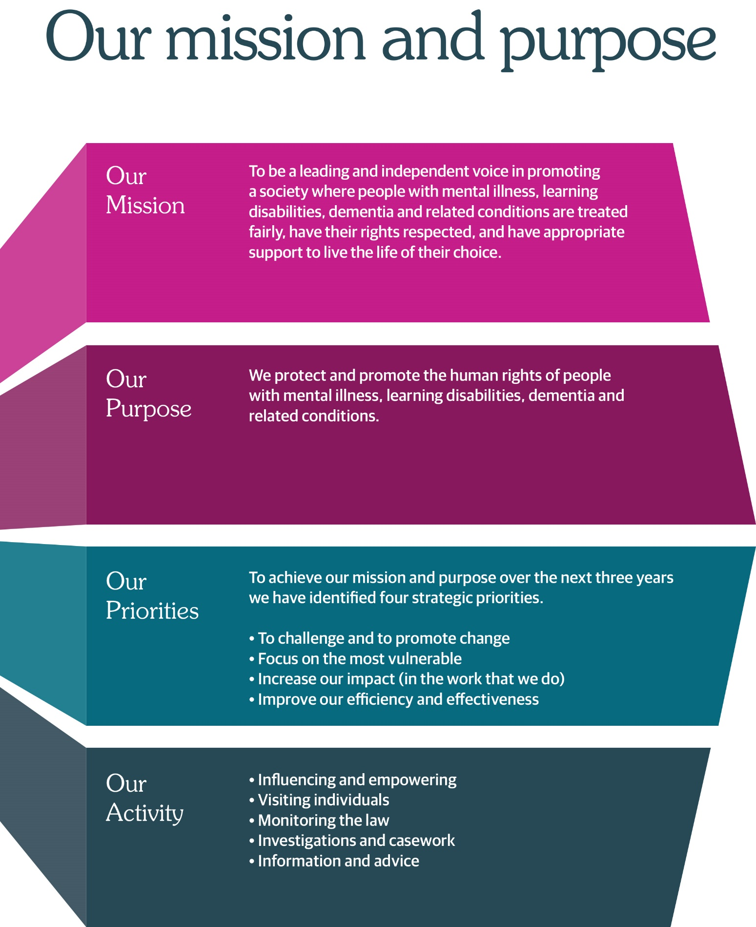

Finance Officer
Part time – 17.5 hours
Edinburgh (Haymarket)
(hybrid working options)
Fixed term contract (12 months)
£35,410 to £38,281 (£17,705 - £19,140 pro rata)

The Commission protects and promotes the human rights of people with mental illness, learning disabilities, dementia, and related conditions.

Our mission is to be a leading and independent voice in promoting a society where people with mental illness, learning disabilities, dementia and related conditions are treated fairly, have their rights respected, and have appropriate support to live the life of their choice.
People who work at the Commission play a vital role in promoting rights and welfare of some of Scotland’s most vulnerable people. It’s challenging and rewarding work that relies on excellent communication skills and the ability to work well as part of a team.

An opportunity has arisen for an enthusiastic and motivated individual to join our small Finance team. This role is part of a small Finance team that responds flexibly and efficiently to the growing demands of the Commission.
The post-holder will work closely with the existing Finance Officer and report to the be responsible for the Finance Manager. The role covers a full and varied range of Finance tasks, including management accounting, accounts payable, payroll, pensions, financial policies and procedures, procurement and external/internal audit activities.

We are looking for someone who brings:

- A formal Association of Accounting Technicians (AAT) Qualification or equivalent
- Substantial practical experience in a Finance role with significant experience of management accounting, accounts payable and payroll.
- Excellent written and oral communication skills.
- Flexibility to support with a broad range of finance duties.

Closing date for receipt of applications is 23 June 2026 at midday. It is anticipated interviews will be held in our office in Edinburgh week commencing 13 July.

Job Description

Job Title: | Finance Officer
Reports To: | Finance Manager

2 | Job Purpose  To undertake day to day operational duties of the Finance and Payroll Functions with minimal supervision, ensuring full compliance with Commission policies.

3 | Dimensions  This post reports into the Finance Manager (0.8 FTE) and works alongside another Finance Officer (1 FTE). It covers all areas of Finance, including:  - Provision of financial support services for a 2026-27 budget of over £7 million  - Preparation of additional expenditure analysis as required  - Approx 75 permanent staff  - Oversight of payroll processes for all permanent and fee paid staff  - Administration of NHS pension scheme  - Accounts Payable and Invoice Processing  - Travel and Subsistence claims  - Preparation of supporting information for audit purposes

4 | Key Result Areas  - Assist in the preparation of Monthly Budget Statement (Management Accounts) to agreed timetable including reconciliation of data, detailed payroll analysis and accruals.  - Ensure all Commission Purchases are correctly processed and recorded in Scottish Government’s Oracle Accounting System. Report on all transactions on a monthly basis, including investigation of any unusual items, ensuring integrity of financial data and prompt settlement of invoices within set Scottish Government deadlines.  - Efficient and accurate administration, analysis and reconciliation of payroll records and pension schemes ensuring compliance with legislative requirements and correct accounting.  - Support Finance Manager in production of annual accounts and supporting working papers in accordance with agreed timetable, ensuring an efficient year end process.  - Maintain the petty cash bank account ensuring all transactions are bona fide and correctly posted to the General ledger. Undertake regular reconciliations and reconcile to the general ledger.  - Ensure Travel and Subsistence is correctly administered and that staff fully understand the process ensuring bona fide claims are paid on time in line with Commission policy.

5 | Planning & Organising  The post-holder will plan and organise most of their own work, although reporting deadlines will dictate some work patterns.  The Finance Manager will review the work by way of the month end process and regular meetings. The Finance Manager and the Finance Officers work closely together ensuring the efficient transfer of information. The post-holder is required to manage the various finance tasks allocated and highlight any issues to the Finance Manager.  Review of performance in the post is conducted by way of regular one to one meetings and review of development throughout the year.  The post-holder is required to manage daily, weekly, monthly and annual tasks ensuring all responsibilities are met in line with the relevant Financial Policies; i.e. Standing Financial Instructions and Financial Operating Procedures. However, the post-holder is also required to perform ad hoc tasks within this structure.

6 | Internal & External Relationships  In addition to the Finance Manager, the following are key working relationships:  - The role requires liaison with Scottish Government Finance and Payroll staff to exchange information.  - The post-holder liaises with all levels of staff in the organisation for payroll, Accounts Payable and Travel & Subsistence. This requires exchange of information, negotiation and training.  - The post-holder is required to liaise with the Pension Agency to exchange information.  - The post-holder is required to liaise with Internal and External Auditors, providing information.  - The post-holder must liaise with external suppliers.  - The post-holder must liaise with external fee paid staff

7 | Most Challenging Aspects of the Job  Ensuring suppliers are paid in accordance with Scottish Government payment deadlines. The payroll is complex: there is a main payroll for permanent staff, a monthly fee system for Second Opinion doctors, seconded staff in and out (invoices) and all must be paid correctly and on time.  Managing the many competing priorities of the role and multi-tasking to ensure key deadlines are met.

8 | Skills/Qualifications & Experience  Essential:  - A formal Association of Accounting Technicians (AAT) Qualification or equivalent.  - Substantial practical experience in a Finance role with significant experience of management accounting, accounts payable and payroll.  - Ability to plan and organise work effectively and to work under minimal supervision.  - Excellent written and oral communication skills.  - Flexibility to support with a broad range of finance duties.  - IT proficiency (advanced excel, large accounting systems and word).  Desirable:  - Educated to degree or equivalent level in a relevant subject  - Experience of a shared services arrangement  - Experience with Oracle  - Prior experience in, or knowledge of, the public sector

9. Sign Off

Job Holder………………………… Date…………………

Manager………………………… Date………………

Person Specification
Finance Officer

In order to be shortlisted you must demonstrate you meet all the essential criteria and as much of the desirable as possible. When a large volume of applications are received for a vacancy and most applicants meet the essential criteria, then the desirable criteria is used to produce the shortlist.

Criteria | Essential | Desirable | How assessed
Qualifications & Training:  Level of education, professional qualifications, training and learning programmes/courses. | - AAT or equivalent, fully or partly completed | - Educated to degree in a relevant subject, or equivalent level of experience | A
Experience:  Length and type of experience, level at which experience gained. | - Experience of all aspects of finance function from accounts payable through to management accounts preparation | - Experience of shared services arrangements | A / I
Knowledge:  Depth and extent of knowledge. | - Knowledge of book-keeping and management accounting key principles | - Knowledge of public sector finance requirements in Scotland | A / I
Skills/Abilities:  Range and level of skills  i.e. communication (oral, written, presentation),  planning/organisation,  numeracy, leadership etc. | - Ability to plan and organise work effectively and to work under minimal supervision  - IT proficiency in the use of Microsoft Office packages  - Prepare and present reports to senior management  - Excellent communication skills both written and oral  - Experience of dealing with key stakeholders at all levels both within the organisation and externally | - Experience with Oracle | A / I

Criteria | Essential | Desirable | How assessed
Specific Job Requirements:  Environmental conditions, unsociable hours, car driver etc. | - Flexible approach to work pattern |  | A / I

Key – how assessed
A = Application | I = Interview

Employment Information – Finance Officer

The following notes summarise the key points of the terms and conditions.

Full details will be provided with offers of employment.

Headquarters | Thistle House, 91 Haymarket Terrace, Edinburgh, EH12 5HE (hybrid working options)
Pay | £35,410 to £38,281 (£17,705 - £19,140 pro rata)
Type of Contract | This post is offered as a 12 month fixed term contract.
Manager | The post-holder reports to the Finance Manager
Hours of work | 17.5 hours, exclusive of breaks but the hours of attendance may be varied, by agreement, to meet the needs of the work.
Leave | Annual Holidays  The annual entitlement for full time posts is 25 days per year, rising to 30 days after 10 years’ relevant service. (NHS and local authority service is counted as relevant service). Leave entitlement is pro-rata for part-time posts.  General/Public Holidays  Public and privilege holidays total 11.5 days per leave year, 6 of these are on set dates and the remainder can be taken as required.  For part time posts, the public/privilege holiday entitlement is pro-rata to full time equivalent.  The leave year runs from 1st April to 31st March.
Superannuation | NHS Pension Scheme is available to all staff subject to scheme rules.  Please click here for contributions details.  The employer currently contributes an amount equal to 22.5% of pensionable pay into the scheme on members’ behalf.
Staff Benefits | Through the Commission Staff Benefits scheme there is access to a wide variety of offers and discounts from the UK’s most popular retailers and service providers. The current provider is EdenRed. There is also access to, My Gyms discount site, the UK's largest network of gyms, studios, fitness centres and sports clubs across the UK with discounted membership offers. A comprehensive Employee Assistance Programme is also available and access to a Cycle to Work Scheme.  (The Commission reserves the right to withdraw, amend the schemes and change providers as appropriate)
Our values | The Commission operates a set of internal values for staff.
Performance, Learning and Development | There is a performance development system in operation within the Commission. Progression through the salary scale is subject to satisfactory performance.
Data protection | The information you provide on the application form and any supplementary forms will be used to assist in the process of recruitment and selection in accordance with the Policy of the Mental Welfare Commission.  If you are successful in your application the information you provide will be used for HR and Payroll purposes. By signing the declaration section of the application form it is understood that you consent to the use and storage of your personal information for the above stated purposes.
Work outside the Commission | It is important to identify and minimise any conflicts of interest that could prevent staff from making fair and objective judgements or could be perceived as doing so by people with lived experience and carers, practitioners and the public. Details are contained in the Commission’s Conflict of Interest Policy. Please note that employees may not be members or employees of the Mental Health Tribunal for Scotland while working for the Commission.
Probationary period | The post requires a 3 months’ probationary period.
Disclosure Scotland | The post requires a Disclosure Scotland Standard Certificate.
Occupational Health Screening | Any offer of employment is subject to satisfactory Occupational Health clearance. The successful candidate will be asked to complete a Pre-Employment Health Questionnaire. NHS Lothian Occupational Health will make an assessment on your fitness to carry out the post based on the information contained within the questionnaire. In certain circumstances further information is required before clearance can be given and Occupational Health may contact you by telephone or request that you attend for an appointment. Clearance must be obtained before any new employee commences employment. Clearance may be subject to you attending for a Post-Employment appointment and it is vital that you attend this appointment if required.
Complaints | The Commission has a Complaints Handling Procedure. All applicants have access to it if they feel they have been unfairly treated during the recruitment and selection process. External applicants should direct any concerns to the Human Resources department and internal applicants have recourse to the Commission’s Grievance Procedure.
Equal opportunities | The Commission is an equal opportunities employer.
Feedback | We do recognise the time and effort it takes to apply for a position. Following the short-listing process, you will be notified about the outcome of your application by email.

How to Apply

The Mental Welfare Commission encourages applications from all sections of the community.

We hope the information we have provided will encourage you to find out more about this opportunity.

To apply, please complete the application form, and email to; mwc.recruitment@nhs.scot

Closing date for receipt of applications is 23 June 2026 at midday. It is anticipated interviews will be held in our office in Edinburgh weeks commencing 13 July.

