
Administration Officer

April 2026
Job Pack
Contents
Foreword 3
Advert 5
Job Description 6
Personal Specification 11
Employment Information – Administration Officer 13
How to Apply 15



Foreword
Dear Candidate

Thank you for your interest in this post and in the Mental Welfare Commission (the Commission).
Our Mission is to be a leading and independent voice in promoting a society where people with mental illness, learning disabilities, dementia and related conditions are treated fairly, have their rights respected, and have appropriate support to live the life of their choice.
It is an exciting time to join the Commission to contribute to our strategic priorities, challenging and promoting change, focusing on the most vulnerable, increasing our impact and improving our efficiency and effectiveness.
This is an opportunity to contribute your experience to supporting the Commission to make a difference to individual’s lives in an independent, national organisation focussing on the rights of individuals across Scotland. Our recent reports on monitoring mental health and incapacity legislation and our themed visits highlight the work that you will be involved in.

For further information on our organisation, please click on our web-link.
Our modern office is based in central Edinburgh, very close to Haymarket Railway station and is served with very good public transport links across Scotland. As an organisation, we work Scotland wide and serve different regions within our teams.
We offer:
- a comprehensive range of HR policies including policies to help balance commitments at work and home and flexible family friendly working arrangements
- training and development opportunities
- access to occupational health services
- access to an employee assistance programme
- access to staff benefits/staff discounts
- a cycle to work scheme
- access to the NHS pension scheme

The following information will help you with your application:
- recruitment advertisement
- job description
- person specification
- terms and conditions of employment information sheet

We hope you are encouraged to apply and look forward to receiving your application.

HR Recruitment team
r Mission and Purpose
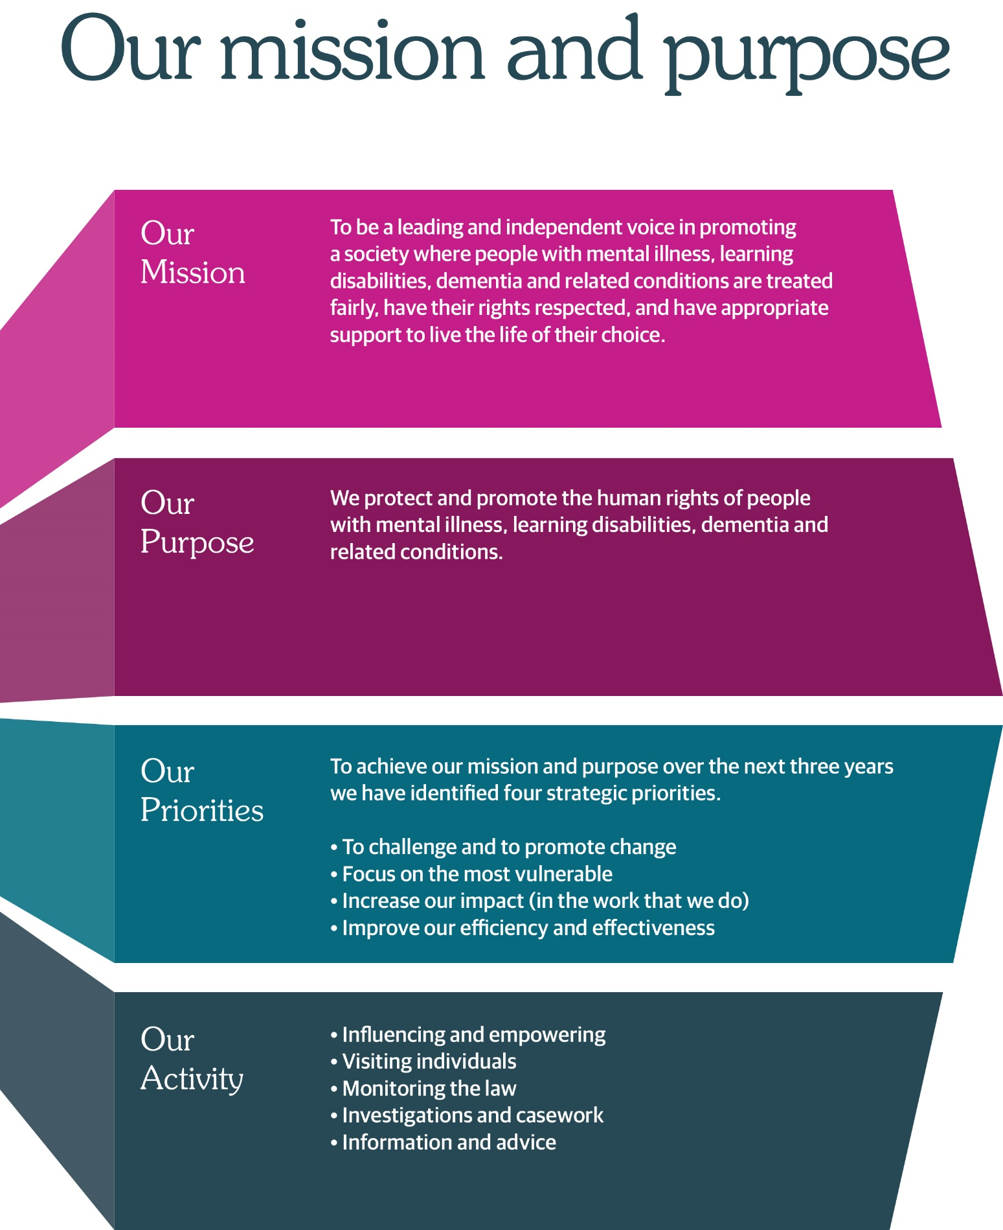

Advert
Administration Officer (to the Executive Leadership Team)
Full Time – 35 hours
Edinburgh (Haymarket)
(hybrid working options)
12 month fixed term contract
£30,574- £32,256 per annum

Our mission is to be a leading and independent voice in promoting a society where people with mental illness, learning disabilities, dementia and related conditions are treated fairly, have their rights respected, and have appropriate support to live the life of their choice. People who work at the Commission play a vital role in promoting the rights and welfare of some of Scotland’s most vulnerable people. It’s challenging and rewarding work that relies on excellent communication skills and the ability to work well as part of a team.
An opportunity has arisen for an enthusiastic and motivated individual to join our Corporate Administration Team to provide a professional, effective, and high-level confidential support service to the Chief Executive and other members of the Executive Leadership Team.
We are looking for an enthusiastic and focused professional who has the relevant qualification or equivalent experience, experience working for a senior executive within a complex organisation, proficient at minute-taking for board and committees, and excellent written and oral communication skills.

For a job pack, please visit the website at Work with us | Mental Welfare Commission for Scotland (mwcscot.org.uk)or contact HR on 0131 313 8783
To arrange an informal discussion, please email the Office Manager (katrina.thomson3@nhs.scot).
Closing date for receipt of applications is 12 noon, 17 April 2026. It is anticipated that interviews will be held on 29 April 2026 at our office in Edinburgh.
For more information on the job, please visit the website at:
Work with us | Mental Welfare Commission for Scotland (mwcscot.org.uk)

Job Description

Job Title: | Administration Officer (to the Executive Leadership Team)
Reports To: | Office Manager

1 | Job Purpose
Post 1: Administration Officer to the Chief Executive/Executive Leadership Team
- Board
- Audit, Performance & Risk Committee
- Support to Chief Executive Officer/ Executive Leadership Team with national groups
- Cover for other Board Committees

The post-holder provides comprehensive secretarial and administrative support to the members of the Executive Leadership Team to allow them to meet their daily commitments and long-term objectives. This post primarily supports the Chief Executive Officer/Executive Leadership Team across a range of administrative work supporting various committees and groups.

2 | Dimensions
The post-holder is part of the corporate administration function of the Commission and will provide support to all members of the Executive Leadership Team.

The role contributes to the perception which external stakeholders have of the Commission through the establishment of positive relationships with our range of contacts, including people with lived experience, their carers and families, staff in Scottish Government, health and social care, NHS, local authorities and partner organisations, e.g. Care Inspectorate.

Executive Leadership Team

Chief Executive

3 | Role of the Mental Welfare Commission
We protect and promote the human rights of people with mental illness, learning disabilities, dementia, and related conditions.

We do this by:

- Checking if individual care and treatment is lawful and in line with good practice.
- Empowering individuals and their carers through advice, guidance, and information.
- Promoting best practice in applying mental health and incapacity law.
- Influencing legislation, policy, and service development.

4 | Key result areas
- To provide a high quality secretarial and administrative service to the Chief Executive/Executive Leadership Team, including prioritising and distributing mail, email management, initiating action required and setting/noting deadlines, drafting letters and collating information to ensure timeous response.

- To provide high level secretarial support for specific corporate committees and/or relevant groups e.g. Board, including accurate minute taking. Manage and co-ordinate both regular and ad-hoc meetings as required, preparing agendas/papers for meetings to ensure meeting papers/reports are received and issued timeously, liaising with responsible officers as required, and format to ensure consistent corporate standards.

- To develop and maintain computer applications for planning, storage, archiving of information and reduction of paper-based systems, and operate an effective electronic filing system to allow retrieval of information quickly and efficiently.

- To exhibit a high level of confidentiality, sensitivity and political awareness and to ensure that the high-profile nature of the work is maintained at all times.

- Responsible for the management of the Chief Executive/Executive Leadership Team’s busy diaries to ensure effective and appropriate use of their time.

- Facilitates meetings by arranging venues/facilities, prepares agendas and circulates relevant papers and also attends meetings, when required, taking an accurate minute and following up any actions deemed appropriate.

- Proactive in initiating action required from information received by email, telephone or correspondence, much of which will be of a highly confidential or sensitive nature, and thereafter prioritising and redistributing so that important or urgent issues are dealt with promptly.

- To manage an ‘extensive bring forward and filing’ system, which provides the Chief Executive/Executive Leadership Team with the necessary paperwork for all meetings, both local and national ensuring that any additional materials are sourced and available to the Chief Executive/Executive Leadership Team.

- To maintain a register of all good practice guidance -- reminding owners when they become due for review.

- To produce presentations for the Chief Executive/Executive Leadership Team using PowerPoint for use on multi-media and notes.

- Responsible for reviewing and updating the pages within the Commission intranet, uploading information, e.g., policies and procedures and ensuring the content is accessible and well presented.

- To provide cover for Office Manager and other Administration Officers within the Commission as required providing cover for secretarial and administrative support.

- To provide support to the Office Manager to ensure all office systems are in place for the staff in the Commission, e.g., stationery stock control, office equipment.

The post-holder may be asked to perform other duties within the responsibility of the post which are not shown above. Equally, changes may become necessary due to changes in work patterns which could cause the duties to be amended. Any amendments will be made in consultation with the post-holder.
5 | Planning and organising
The post-holder is line managed by the Office Manager who will ensure delivery of the corporate administration function to the Executive Leadership Team.

The Chief Executive/Executive Leadership Team sets priorities and the post-holder enjoys significant autonomy on a daily basis to plan and carry out their work.

The post-holder will contribute to multiple pieces of work concurrently and will need to adjust priorities to meet changing demands.

The post-holder will participate in the formal objective setting and performance appraisal process of the Commission and will take a proactive approach in the formulation of a personal development plan.

6 | Internal & External Relationships
Internal
To develop and maintain good working relations with staff within the Commission, dealing with sensitive and confidential information, developing effective working relationships and promoting team working, efficient practice and timeous decision making. At all times the post-holder has to be aware of the need to maintain the corporate identity of Commission in any communications that they have.

External
Regular contact by e-mail/telephone with Scottish Government, Health & Social Care Partnerships, Health Board and Local Authorities.

7 | Most challenging aspects of the Job
The post-holder must have the ability to manage a highly complex and demanding workload, to meet tight deadlines, have a high degree of confidentiality and have a very flexible approach to work patterns.

As primary point of contact with Directors, Senior Managers and staff within the Commission and external partners this requires highly developed judgement skills when confidential, sensitive or contentious issues arise.

The post-holder must also have an awareness of potentially sensitive political issues and the high-profile nature of the work of the Commission.

8 | Skills, qualifications, and experience
- A relevant secretarial qualification at HNC level or equivalent experience.
- In addition, significant experience working for a senior executive within a complex organisation.
- Must be proficient and comfortable at minute taking for boards/committees.
- Advanced knowledge of Microsoft office packages, word, excel, outlook, teams and PowerPoint.
- Ability to organise and work under pressure whilst meeting tight deadlines.
- Self-motivated person with excellent organisational, communication (both written and verbal) and interpersonal skills.
- Able to devise detailed administrative processes.

Personal Specification

Administration Officer

In order to be shortlisted you must demonstrate you meet all the essential criteria and as much of the desirable as possible. When a large volume of applications are received for a vacancy and most applicants meet the essential criteria then the desirable criteria is used to produce the shortlist

Criteria | Essential | Desirable | How assessed
Qualifications & Training  Level of education, professional qualifications, training and learning programmes/courses. | - A relevant secretarial qualification at HNC level or equivalent level of experience |  | A
Experience  Length and type of experience, level at which experience gained. | - Proficient at minute taking for boards/committees  - Working for a senior executive  - Experience of information retrieval and presentation |  | A / I
Knowledge  Depth and extent of knowledge. | - Knowledge of GDPR and the governance around handling of sensitive person-specific data. | - Knowledge of the mental health system in Scotland | A / I
Skills/Abilities  Range and level of skills  i.e. communication (oral, written, presentation),  planning/organisation,  numeracy, leadership etc. | - IT proficiency in the use of Microsoft Office packages  - Ability to plan and organise work effectively and to work under minimal supervision  - Excellent communication skills (both written and verbal) |  | A / I
Criteria | Essential | Desirable | How assessed
Specific Job Requirements  Environmental conditions, unsociable hours, car driver etc. | - Flexible approach to work pattern |  | A / I
Key – how assessed
A = Application | I = Interview

Employment Information – Administration Officer
The following notes summarise the key points of the terms and conditions.

Full details will be provided with offers of employment.

Headquarters | Thistle House, 91 Haymarket Terrace, Edinburgh, EH12 5HE (hybrid working options)
Pay | £30,574- £32,256 per annum
Type of Contract | 12 month fixed term contract
Manager | The post-holder reports to the Office Manager.
Hours of work | Full-time posts are 5-days per week of 35 hours, exclusive of breaks but the hours of attendance may be varied, by agreement, to meet the needs of the work.
Leave | Annual Holidays  The annual entitlement for full time posts is 25 days per year, rising to 30 days after 10 years’ relevant service. (NHS and local authority service is counted as relevant service). Leave entitlement is pro-rata for part-time posts.  General/Public Holidays  Public and privilege holidays total 11.5 days per leave year, 6 of these are on set dates and the remainder can be taken as required.  For part time posts, the public/privilege holiday entitlement is pro-rata to full time equivalent.  The leave year runs from 1st April to 31st March.
Superannuation | NHS Pension Scheme is available to all staff subject to scheme rules.  Please click here for current contributions details.  The employer currently contributes an amount equal to 20.9% of pensionable pay into the scheme on members’ behalf.
Staff Benefits | Through the Commission Staff Benefits scheme there is access to a wide variety of offers and discounts from the UK’s most popular retailers and service providers. The current provider is EdenRed. There is also access to, My Gyms discount site, the UK's largest network of gyms, studios, fitness centres and sports clubs across the UK with discounted membership offers. A comprehensive Employee Assistance Programme is also available and access to a Cycle to Work Scheme. (The Commission reserves the right to withdraw, amend the schemes and change providers as appropriate)
Our values | The Commission operates a set of internal values for staff.
Performance, Learning and Development | There is a performance development system in operation within the Commission. Progression through the salary scale is subject to satisfactory performance.
Data protection | The information you provide on the application form and any supplementary forms will be used to assist in the process of recruitment and selection in accordance with the Policy of the Mental Welfare Commission.  If you are successful in your application the information you provide will be used for HR and Payroll purposes. By signing the declaration section of the application form it is understood that you consent to the use and storage of your personal information for the above stated purposes.
Work outside the Commission | It is important to identify and minimise any conflicts of interest that could prevent staff from making fair and objective judgements or could be perceived as doing so by people with lived experience and carers, practitioners and the public. Details are contained in the Commission’s Conflict of Interest Policy. Please note that employees may not be members or employees of the Mental Health Tribunal for Scotland while working for the Commission.
Probationary period | The post requires a 3 months’ probationary period.
Disclosure Scotland | The post requires a Disclosure Scotland Basic certificate and self-declaration.
Occupational Health Screening | Any offer of employment is subject to satisfactory Occupational Health clearance. The successful candidate will be asked to complete a Pre-Employment Health Questionnaire. NHS Lothian Occupational Health will make an assessment on your fitness to carry out the post based on the information contained within the questionnaire. In certain circumstances further information is required before clearance can be given and Occupational Health may contact you by telephone or request that you attend for an appointment. Clearance must be obtained before any new employee commences employment. Clearance may be subject to you attending for a post-Employment appointment and it is vital that you attend this appointment if required.
Complaints | The Commission has a Complaints Handling Procedure. All applicants have access to it if they feel they have been unfairly treated during the recruitment and selection process. External applicants should direct any concerns to the Human Resources department and internal applicants have recourse to the Commission’s Grievance Procedure.
Equal opportunities | The Commission is an equal opportunities employer.
Feedback | We do recognise the time and effort it takes to apply for a position. Following the short-listing process, you will be notified about the outcome of your application by email.

How to Apply
The Mental Welfare Commission encourages applications from all sections of the community.

We aim to have a workforce which represents the wider society that we serve and therefore encourage applications from people of all backgrounds and under-represented groups.

We hope the information we have provided will encourage you to find out more about this opportunity.

For more information on applying or to arrange an informal discussion, please contact the Office Manager (katrina.thomson3@nhs.scot).
If you wish to view more information on applying, please visit our website:
Work with us | Mental Welfare Commission for Scotland (mwcscot.org.uk)

Closing date for receipt of applications is 12.00 noon on 17 April 2026. It is anticipated that interviews will be held in our office in Edinburgh on 29 April 2026
Please securely email your electronic completed application form, marked Private & Confidential to: mwc.recruitment@nhs.scot
Alternatively, you can post your application form to the HR Department. Please mark as Private and Confidential.

HR Department
Mental Welfare Commission
Thistle House
91 Haymarket Terrace
Edinburgh
EH12 5HE

