SOP 1 Form – 2nd Opinion Requests
Use the form to submit 2nd opinion requests for treatment to The Mental Welfare Commission.
When you have completed the form, you may click the Submit to MWC button at the top of page 1. This will automatically create an email addressed to the Commission’s 2nd opinion request mail address, with the completed form attached. All you have to do is click send. Save your own copy of the form.
When you click the submit button, a dialog box will appear asking if you wish to use the default email application or use webmail. Your email will most likely be Microsoft Outlook, the default.
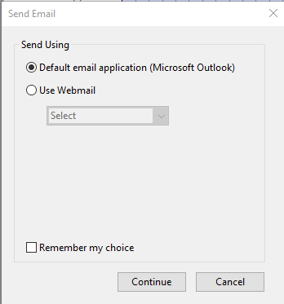
If the Submit button doesn’t work for you, our email address is shown below the button. Simply copy this, save the completed form then email it as an attachment to the copied email address. Title the email 2nd Opinon Request.
The form is in PDF format which will open in Adobe Acrobat. You must have Javascript enabled in Acrobat for the form to function correctly. If it is not already enabled you may see a message like this…
Click on Options and select to always enable Javascript for the document.
